|  |
| --- |
| Network and Computer Security Laboratory |
| EECE 655L  Project  **Identify and Detect Network and System Attacks** |

**Project: Identify and Detect Network and System Attacks**

This project provides hands-on experience with Wazuh for centralized monitoring and alerting of Windows and Linux event logs.

**Project Overview**

In this project, you will:

* Deploy the Wazuh Manager using a pre-configured OVA file in VirtualBox.
* Install and configure Wazuh agents on Windows and Linux VMs.
* Enable and monitor Windows Event Logs (System, Application, Security) and Sysmon logs.
* Create custom rules to trigger alerts for specific events.
* Analyze alerts on the Wazuh dashboard.

**Project Environment**

* VirtualBox with the following VMs**:**
  + **Wazuh Manager OVA:** Pre-configured Wazuh Manager**.**
  + **Windows Server:** Wazuh Agent and Sysmon**.**
  + **Ubuntu Linux:** Wazuh Agent for Linux monitoring**.**
  + **kali Linux:** Wazuh Agent for Linux monitoring**.**

# Project Steps:

**Step 1: Deploy Wazuh Manager Using the OVA Description**

The Wazuh Manager is the central component that collects logs and generates alerts. Using the pre-configured OVA file simplifies the setup process.

# Tasks

1. **Download the Wazuh OVA**
   * Visit the Wazuh Downloads page and download the OVA for VirtualBox. https://packages.wazuh.com/4.x/vm/wazuh-4.9.2.ova

* I will be using Wazuh that I’ve preinstalled on an Ubuntu machine.

# Import the OVA into VirtualBox

* + Open VirtualBox and click on **File > Import Appliance**.
  + Browse to the downloaded OVA file and click **Next**.
  + Adjust the VM settings
    - 16 GB RAM
    - 4 CPU
    - Network Adapter: NAT Network

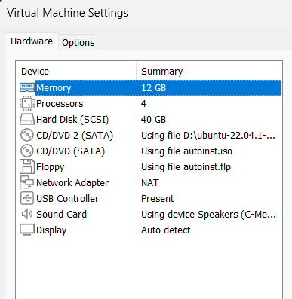

* Avoided using 16GB of RAM as my laptop can’t afford it, allocated 12GB of RAM instead, everything else is as instructed.

# Start the Wazuh Manager VM

* + Select the imported VM and click **Start**.
  + The credentials are displayed on the screen
  + Note the IP address of the Wazuh VM using ifconfig

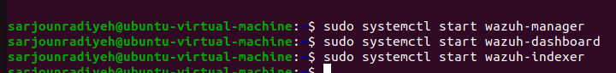

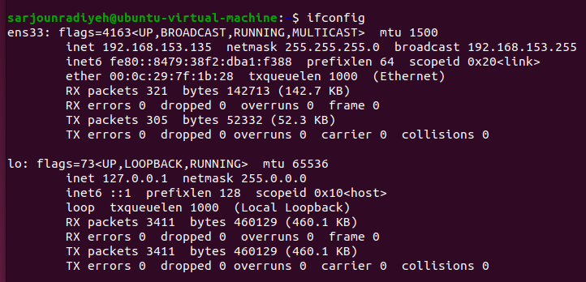

* I started all services needed for Wazuh to run properly, It’s IP is **192.168.153.135**.

# Access the Wazuh Dashboard

* + Open a web browser and navigate to: https://<Wazuh_Manager_IP>:443
  + Default credentials:
    - Username: admin
    - Password: admin

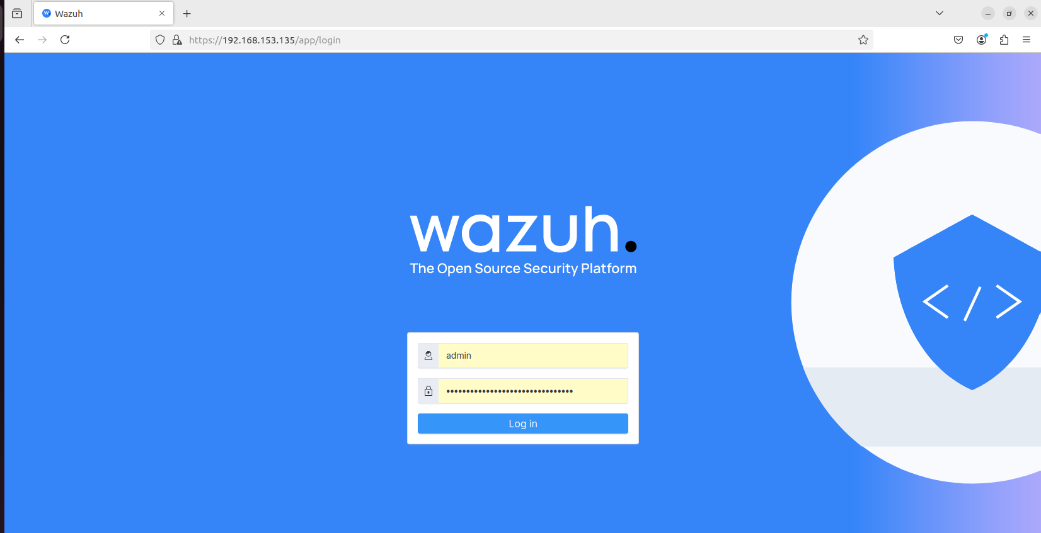

* I opened the Wazuh Login page, seeing my admin username and password (randomized by wazuh on setup).

1. Test Connectivity between the machines and the Wazuh VM

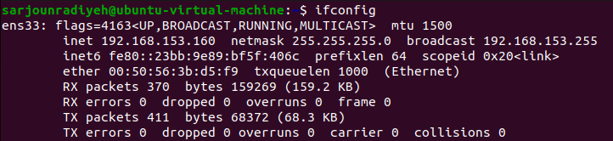

* Ubuntu (**AGENT**) machine’s IP: **192.168.153.160**.

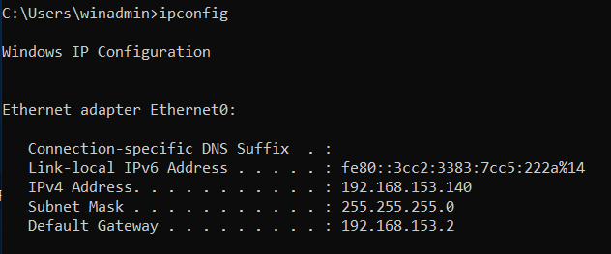

* Windows Server 2019 IP: **192.168.153.140**.

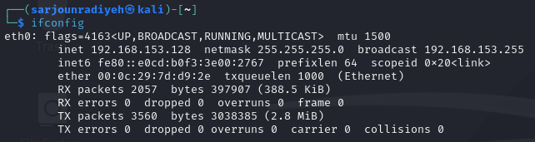

* Kali Linux machine IP: **192.168.153.128** (Won’t be using this machine for this project).

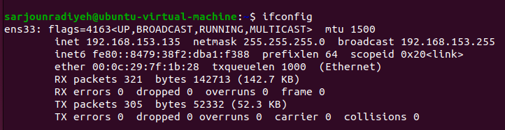

* Ubuntu (**Wazuh**) machine’s IP: **192.168.153.135**.

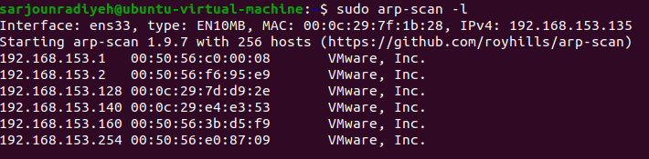

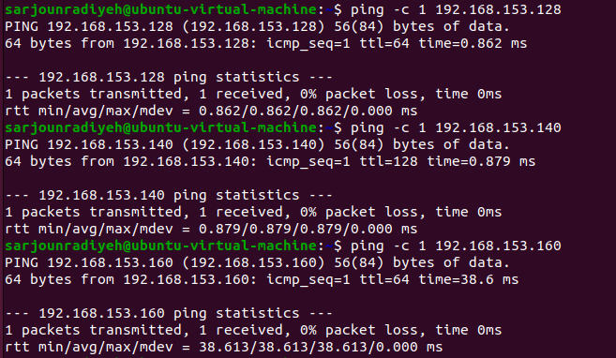

* Did an arp-scan to confirm that the Wazuh machine can see all the devices, then pinged them all to confirm connectivity. I will refrain from pinging from each machine as it is relatively redundant to do so for now.

1. Allow ports 1514 and 1515 (Outbound connections) on windows machine and Ubuntu machine

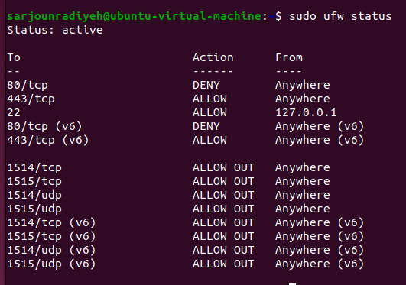

* Enabled ufw and added rules to allow both TCP and UDP Outbound connections for port 1514 and 1515 (for both IPv4 and IPv6 ) on the Ubuntu Agent machine

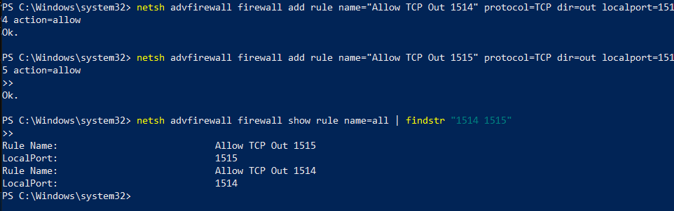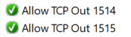

* Created equivalent rules for the Windows Server machine using PowerShell (avoided GUI for clarity) then confirmed it’s existence by showing all rules and filtering it.

# Step 2: Install and Configure Wazuh Agent on Windows Server Description

The Wazuh Agent collects and forwards Windows Event Logs and Sysmon logs to the Wazuh Manager for analysis.

# Tasks

1. Download the Wazuh Agent (Use the Wazuh Dahsboard: Endpoints Summary tab -> Deploy new agent)

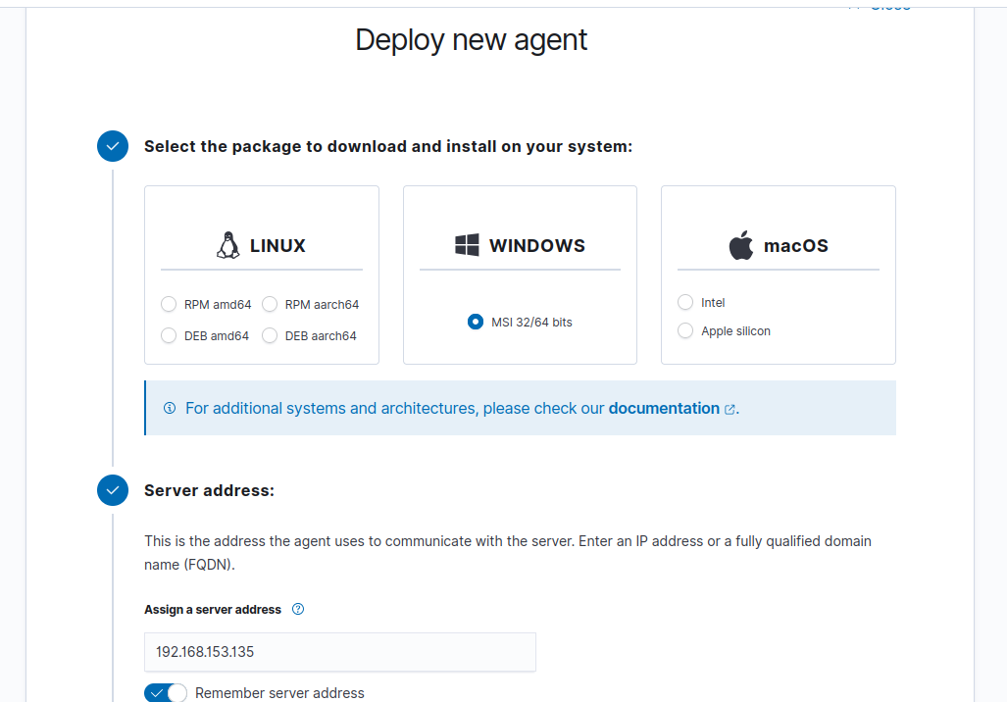

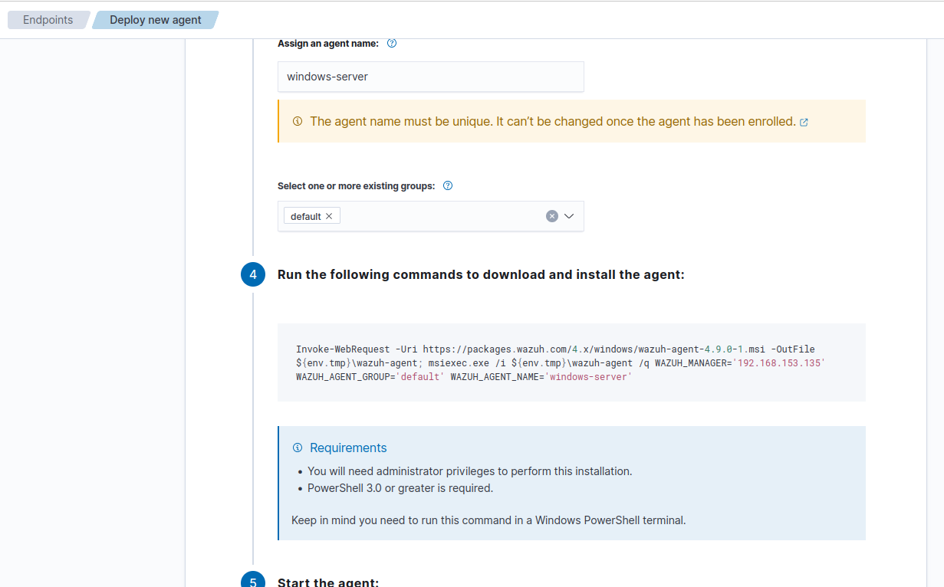

* Went to Deploy Agent page and specified that the agent is Windows, what the name of it should be, what group it belongs to, and who it’s Wazuh Manager is (What IP), received commands to use and moved onto the Windows Server.

1. Install the Agent (During installation, specify the Wazuh Manager's IP address)

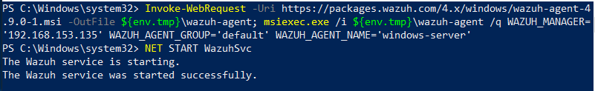

* Executed commands given to setup Wazuh Agent and confirmed the Wazuh service is up and running on the Windows Server machine. The Wazuh Manager’s IP was already specified and implemented into the command, the IP being “**192.168.153.135**”

1. Configure the Agent:
   1. Open the agent configuration file:

"C:\Program Files (x86)\ossec-agent\ossec.conf"

* 1. Make sure that the following entries to monitor Windows Event Logs and Sysmon exist:

<localfile>

<log_format>eventchannel</log_format>

<location>System</location>

</localfile>

<localfile>

<log_format>eventchannel</log_format>

<location>Application</location>

</localfile>

<localfile>

<log_format>eventchannel</log_format>

<location>Security</location>

</localfile>

<localfile>

<log_format>eventchannel</log_format>

<location>Microsoft-Windows-Sysmon/Operational</location>

</localfile>

* 1. Start the Agent : Open Services and Start Wazuh

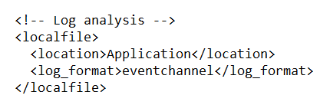 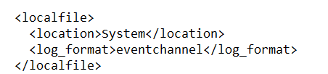

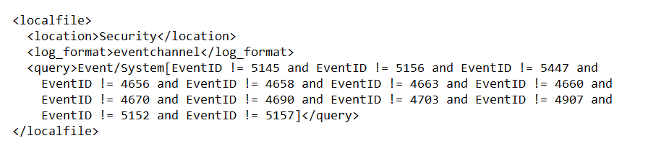

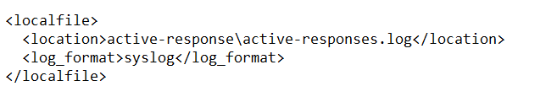 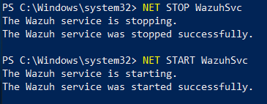

* Confirmed System, Application and Security Event Channel logs were being monitored and added Sysmon logs as it wasn’t present by default. I then proceeded to restart Wazuh.

1. Make sure that the ports 1514 and 1514 are allowed on Windows machine.

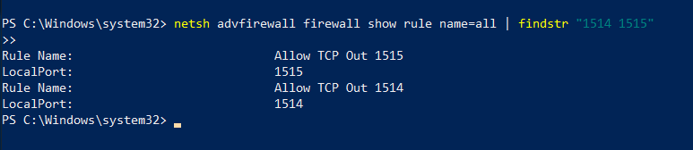

* Confirmed both ports are open again.

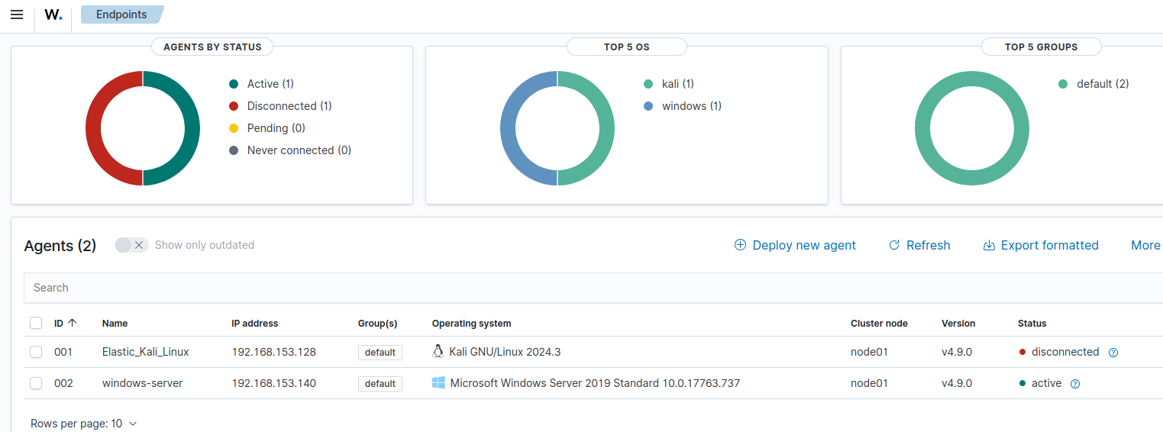

* Confirmed Windows Server shows on the Wazuh Dashboard in Endpoints Summary (Ignore Kali, this is from a previous project).

# Step 3: Install Sysmon on Windows (Already done in previous lab)

Microsoft Sysmon is a tool for advanced logging of process creations, file changes, and network connections.

# Tasks

1. Download from [Sysinternals](https://docs.microsoft.com/en-us/sysinternals/downloads/sysmon).
2. Install Sysmon with a Custom Configuration ([SwiftOnSecurity Sysmon Config](https://github.com/SwiftOnSecurity/sysmon-config)).
   * Install Sysmon: sysmon -accepteula -i sysmon-config.xml
3. Verify Sysmon Logs
   * Open Event Viewer (eventvwr.msc) and navigate to:

Applications and Services Logs > Microsoft > Windows > Sysmon > Operational

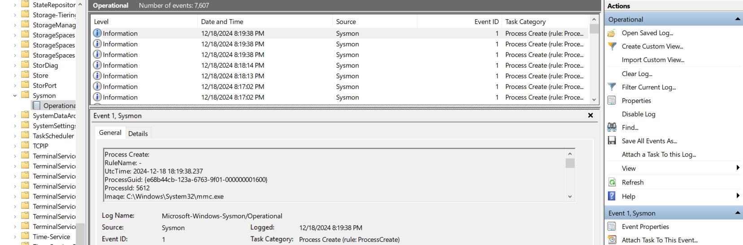

* Confirmed Sysmon is installed and it’s logs are popping up on Event Viewer (Already done in previous lab).

# Step 4: Install and Configure Wazuh Agent on Ubuntu Linux or kali Description

The Linux Wazuh Agent enables monitoring of system activities and file changes.

# Tasks

1. Download and Install the Agent (Use the Wazuh Dahsboard: Endpoints Summary tab -> Deploy new agent)

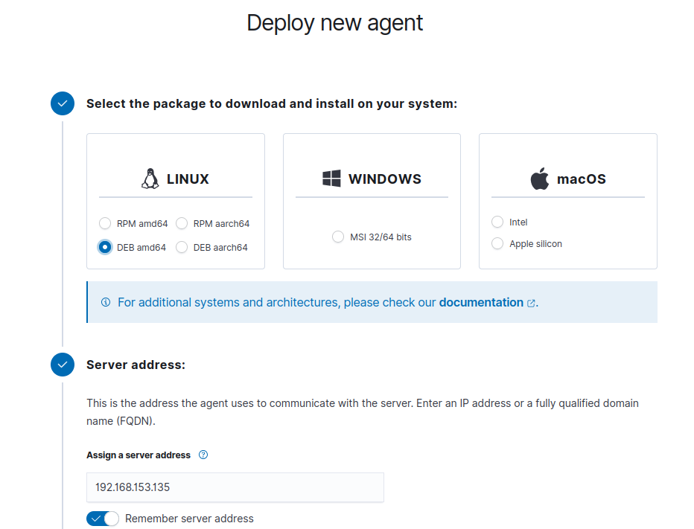

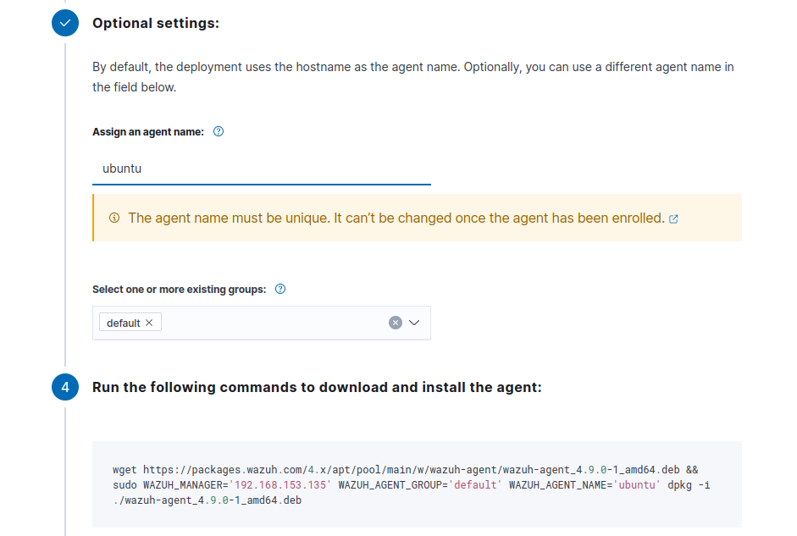

* Again, went to Deploy Agent page and specified that the agent is Linux based, what the name of it should be, what group it belongs to, and who it’s Wazuh Manager is (What IP), received commands to use and moved onto the Ubuntu Agent Machine.

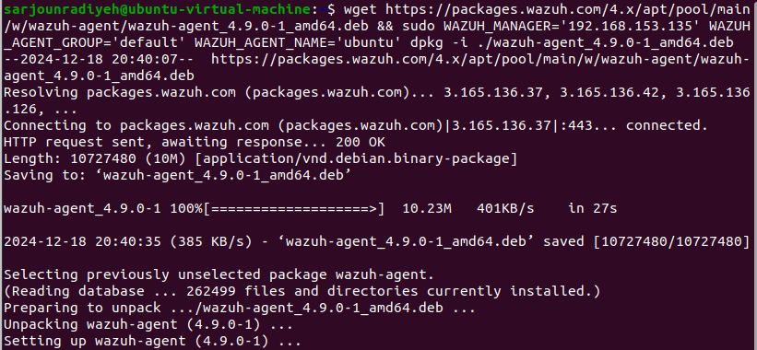

* Installed Wazuh Agent on the Ubuntu Agent machine.

1. Configure the Agent

sudo nano /var/ossec/etc/ossec.conf Add the IP of the Manager:

<server>

<address>192.168.56.101</address>

</server>

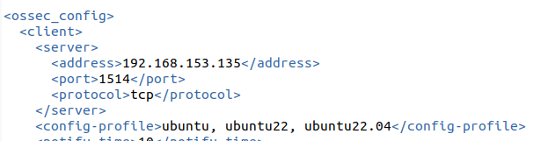

* This has already been done automatically on setup through the command Wazuh provided to us. Confirmed nonetheless.

1. Start the Agent
   1. sudo systemctl enable wazuh-agent
   2. sudo systemctl start wazuh-agent

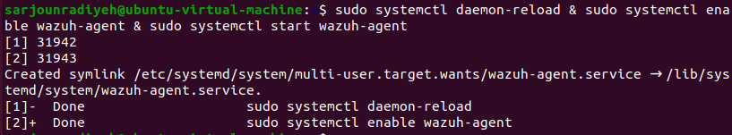

* Started the agent and enabled it to open on startup.

1. make sure that the ports 1514 and 1515 are allowed.

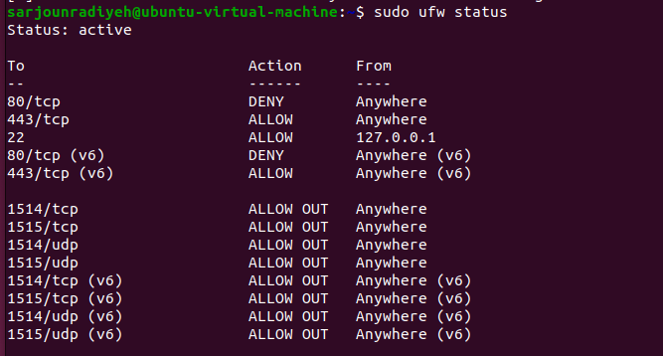

* Confirmed ufw firewall rules allow 1514 and 1515 outbound again.

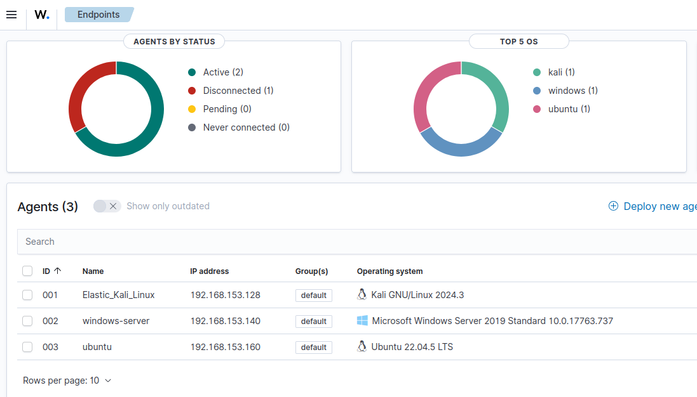

* Confirmed Ubuntu Agent machine is shown on Endpoints Summary dashboard.

# Step 5: Create and Apply Custom Rules

By default, Wazuh provides a comprehensive set of rules for efficient log processing. However, you can create custom rules tailored to your specific data sources to meet unique monitoring requirements.

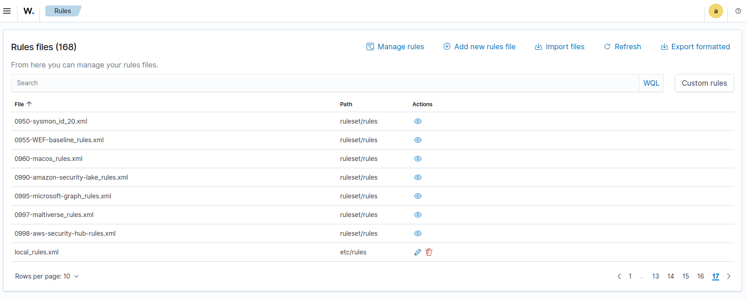

* There is a multitude of rule files on Wazuh however for custom rules we must go to local_rules.xml and modify it according to our needs.

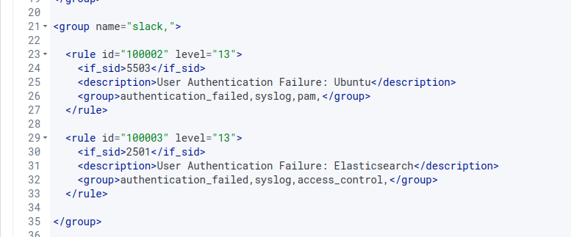

* I’ve personally incorporated my own rules here previously with a “High” alert level, both these rules were authentication-based and created to show custom messages along with a custom alert level and custom grouping for the sake of clarity when proceeding to see these messages on slack (which is why the overall set group name is “slack”).

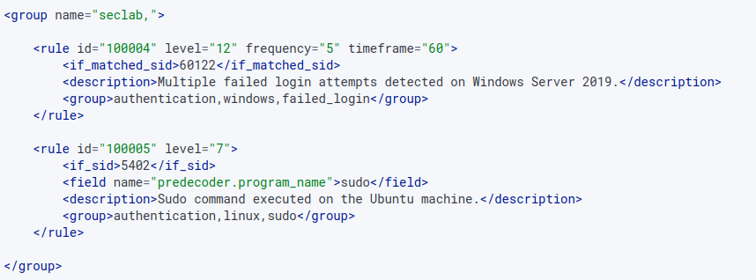

* Added new set of custom rules under the group seclab, one being 10004 and the other being 100005:
  + The 100004 rule has been added to be triggered if the frequency of the rule 60122 is 5 times in 60 seconds (Failed login attempt occurred 5 times in 1 minute). Severity 12, which is high as this is a dangerous indicator of a possible brute force.
  + The 100005 rule has been added to be triggered if the rule id is 5402, the program being executed is sudo, the severity is 7 which is medium given the fact that sudo can be used for normal reasons hence the severity shouldn’t be high, yet nonetheless important to track all successful sudo usage.
* Each of these rules have been added to the “parent” group seclab and have their own custom groups related to their usage….authetnication, windows/linux, sudo etc…

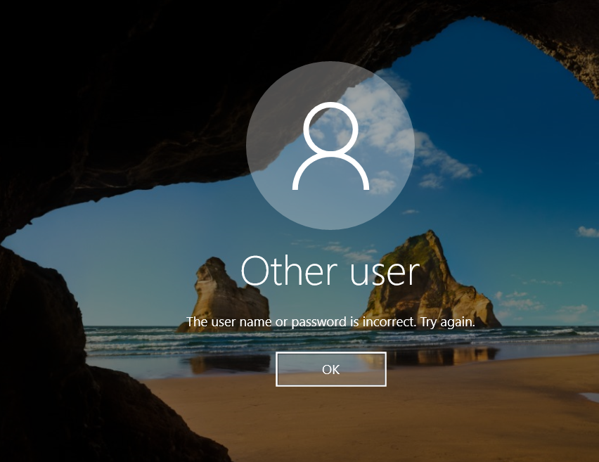

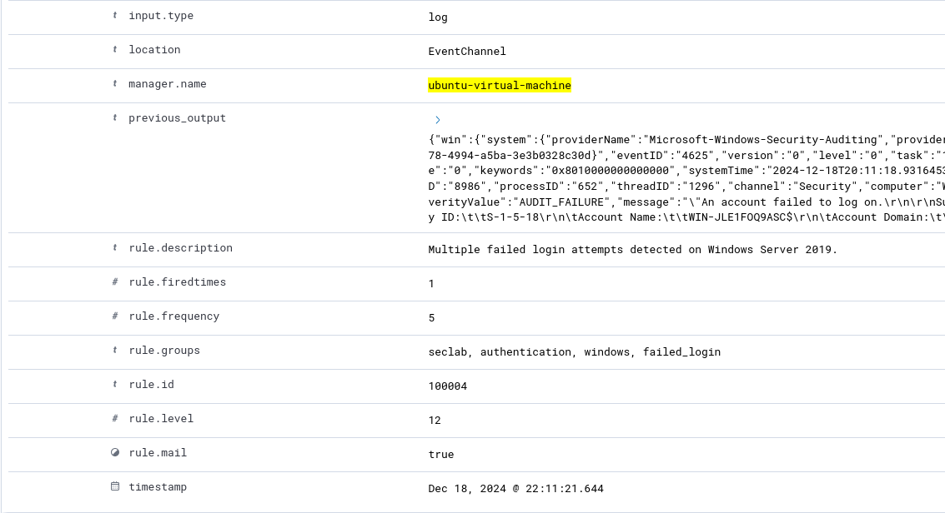

* Confirmed rule works, whenever 5 login attempts happen in 60 seconds, the rule 100004 will be triggered.

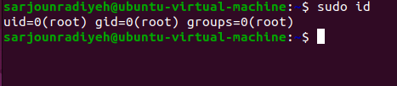

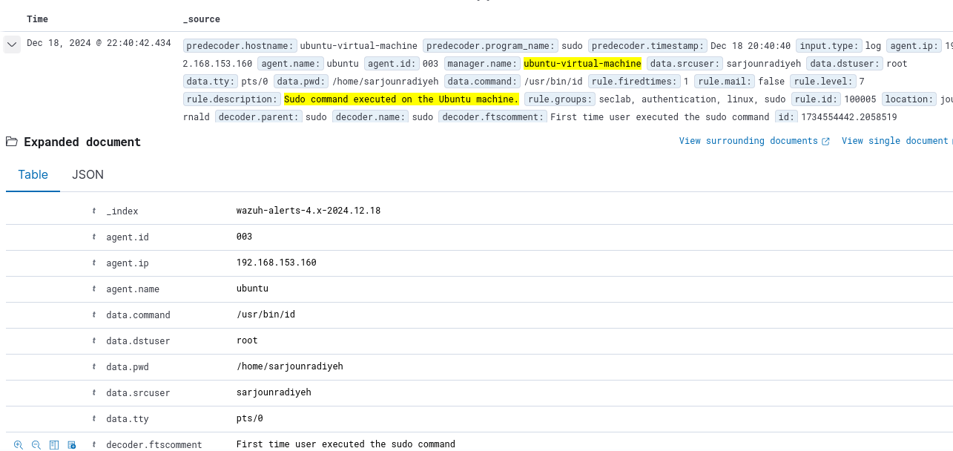

* Confirmed rule works, whenever sudo is typed and is successful the rule 100005 will be triggered.

# Step 6: Enhancement of Visibility

1. Perform some activities on Windows and Linux machines to verify if you receive the appropriate logs from the machines

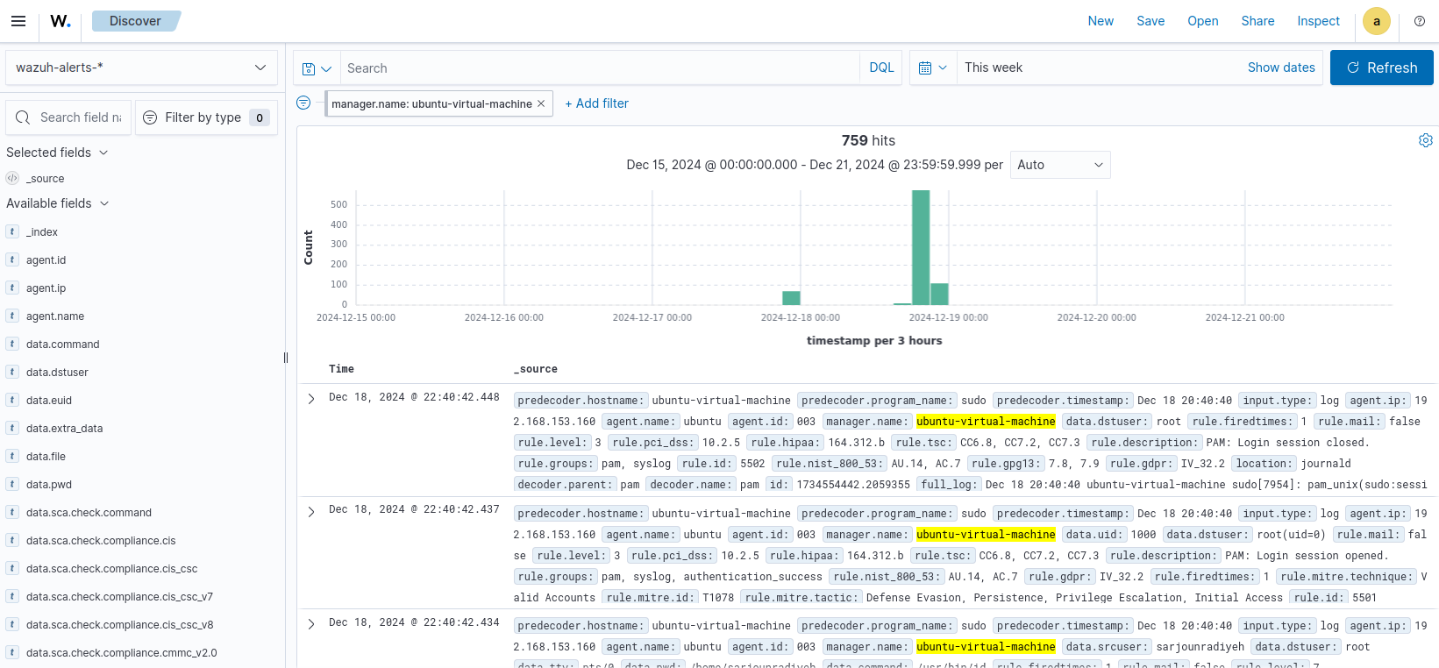

* Here are all the logs I’ve gathered in the past couple of hours from all agents.

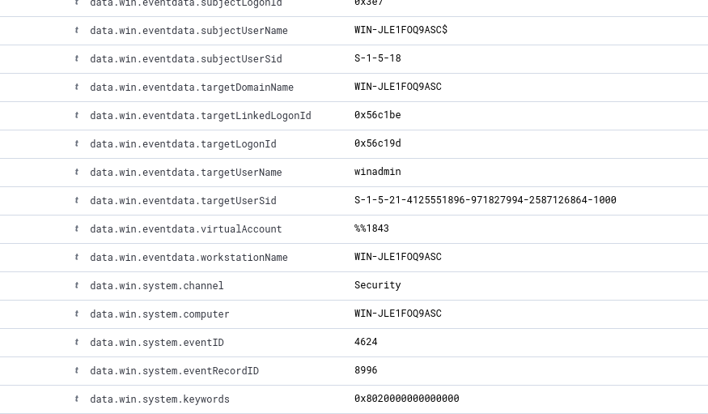

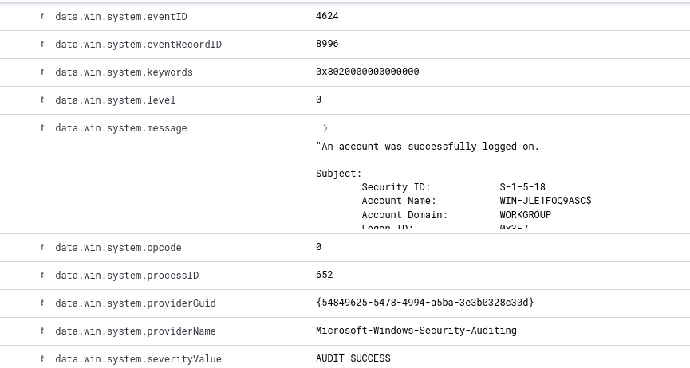

* Successfully logged into the Windows Server and was provided with very specific data (essentially that of Event Viewer but filtered even further for clarity) like the field **data.win.eventdata.targetUserName** which provided me with which user logged in as well as **data.win.system.message** which provided me with the full message in case I want to analyze it alone.

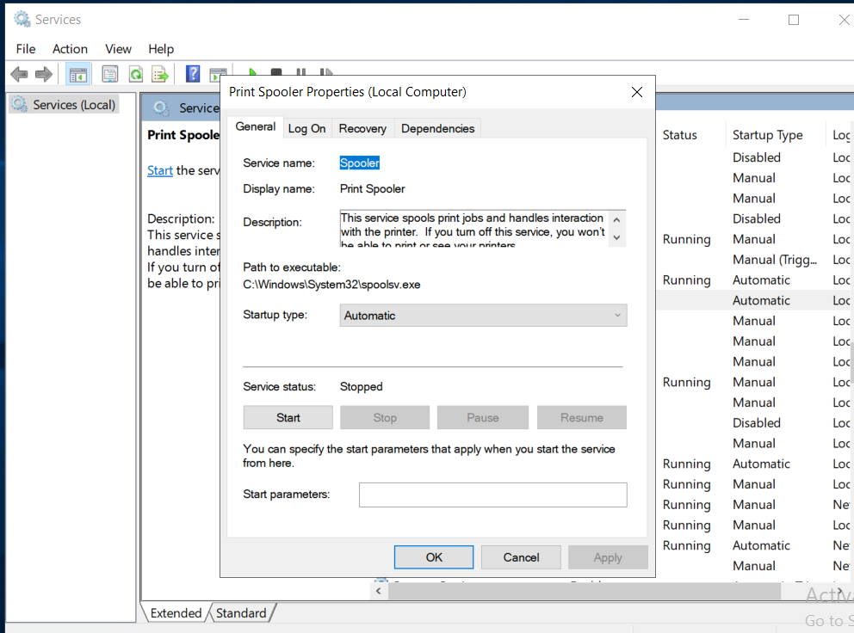

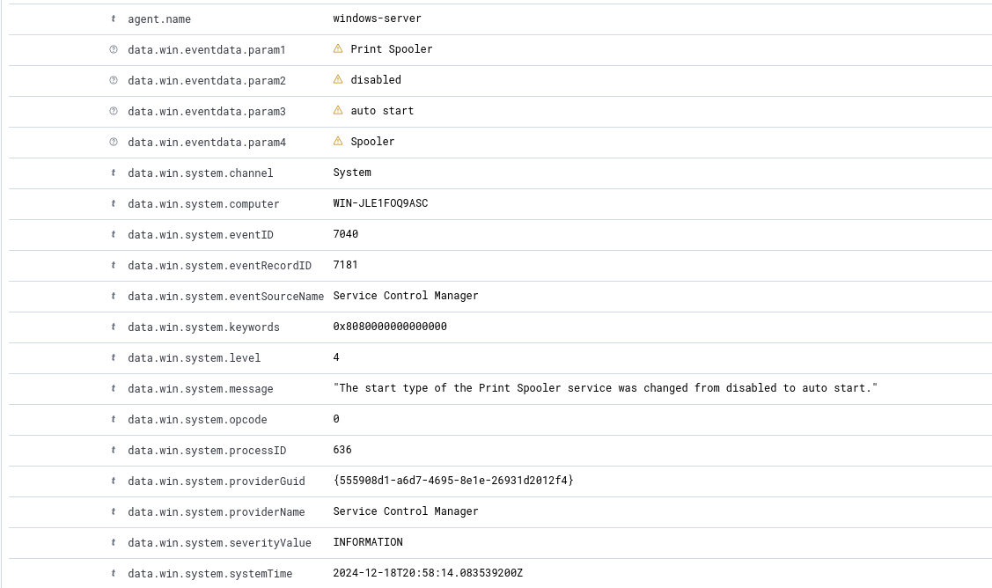

* I changed the start up type of Print Spooler from disabled to automatic and a rule triggered informing me what which specific service startup was modified in the field **data.win.system.message** as well as the time this occurred in **data.win.system.systemTime.**

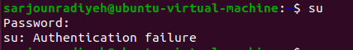

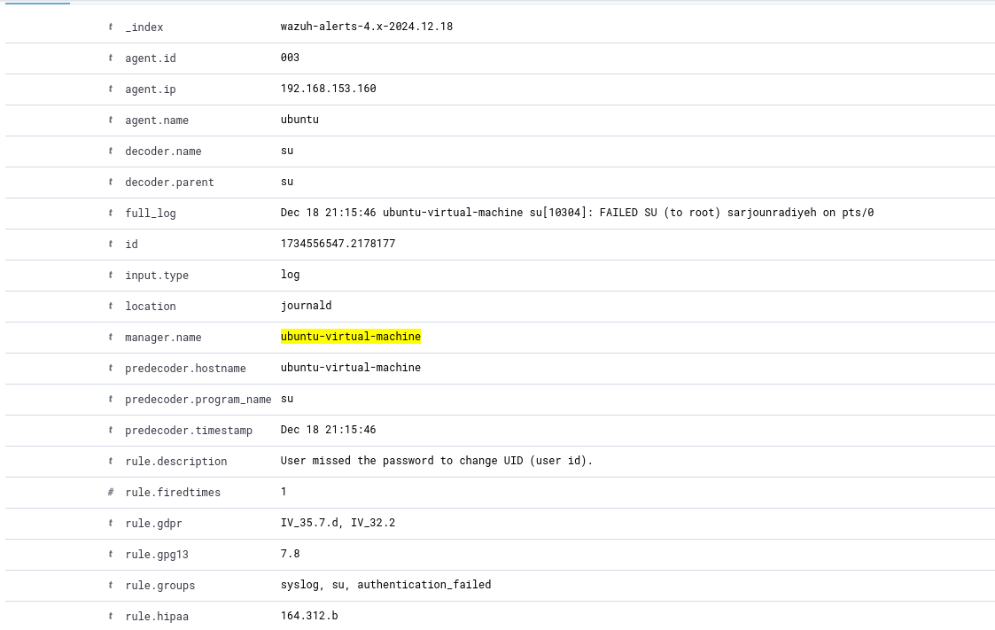

* Failing to switch to root user, a rule is triggered that makes an alert on Wazuh stating the **full_log** (which shows that sarjounradiyeh failed su’ing to root) and the **decoder.timestamp** (the time this occurred according to su, the decoder).

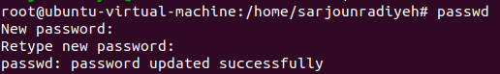

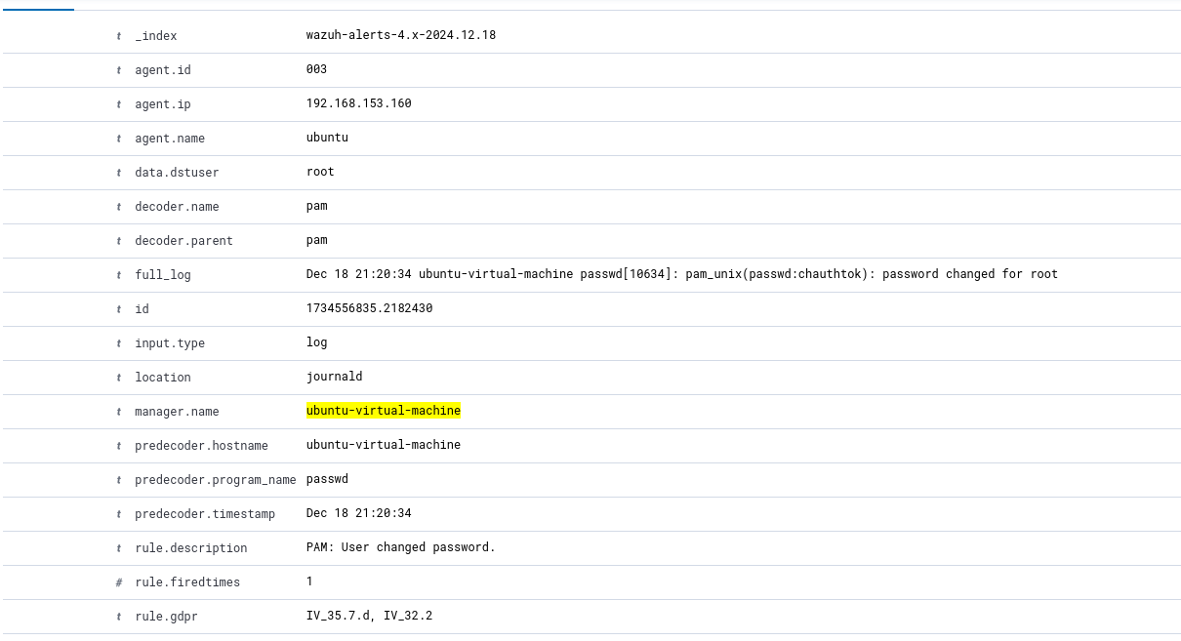

* Root password was changed, rule triggered that makes an alert show up on Wazuh stating the user who’s password was changed, **data.dstuser** amd the **full_log** showing more details.

1. Adjust the configuration in the agents using Wazuh Manager by accessing Endpoint Groups and editing group configuration.

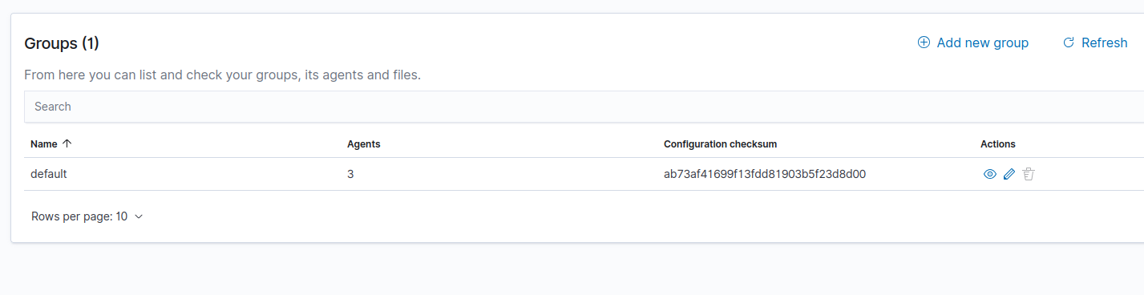

* Opened up Endpoint Groups to see my only group which is “default” and has all the agents in it.

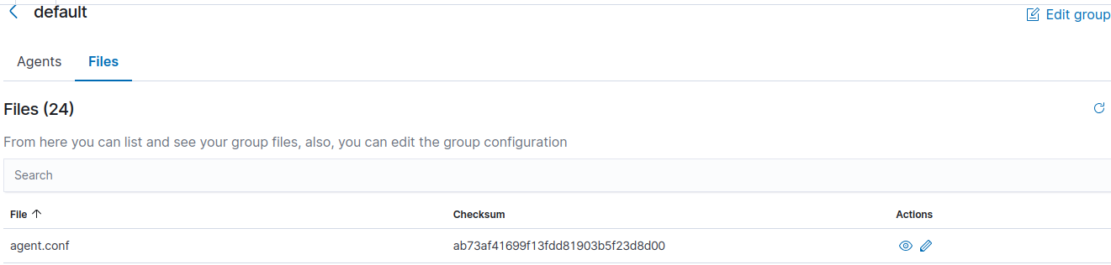

* Let us now modify agent.conf.

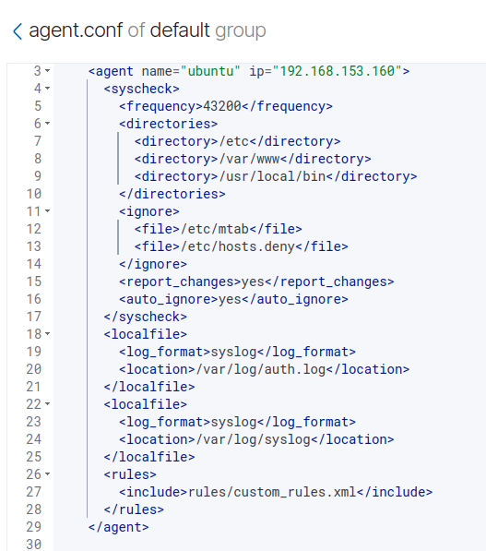

* Successfully configured Syscheck in agent.conf for the windows-server machine by specifying directories like as C:\Windows\System32 and C:\Program Files. for file integrity monitoring. I also included custom rules and configuring log collection for the System and Security event logs (this should be the case for this machine always), this method can enhance consistency when monitoring a group of devices and wanting consistent configurations.

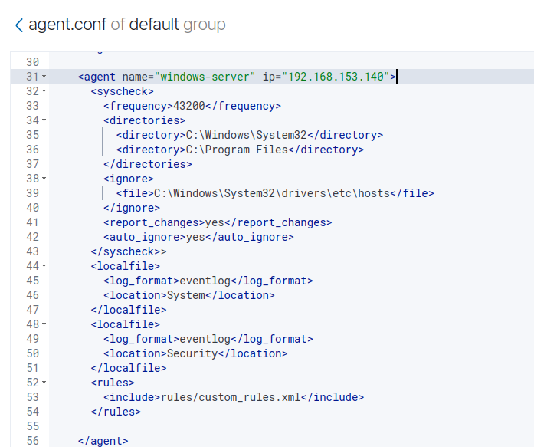

* Configured Syscheck in agent.conf for the ubuntu machine by specifying important directories like /etc, /var/www, and /usr/local/bin. This is for file integrity monitoring to track and alert on any unauthorized changes within these vital directories, ensuring the integrity of critical system and application files. I also included custom rules again and set up log collection for /var/log/auth.log and /var/log/syslog (this should be the case for this machine always). This now helps in remaining consistent for this group.
* These modifications to the agent.conf file for both agents ensures consistent agents and simplifies overall security monitoring.
* We can also do another approach of creating and configuring agent.conf for new groups individually in which case we can group all Ubuntu agents to use the same .conf file and all Windows agents to use the same agent.conf, this is significantly more effective than my approach however we only have 2 agents in this project and what I did is sufficient for a small scale home lab.

1. Update the rules in the Wazuh manager to enhance your visibility. **(DON’T UNDERSTAND EXACTLY WHAT IS REQUIRED HERE…. FORGIVE ME IF IT’S NOT WHAT YOU WANTED)**

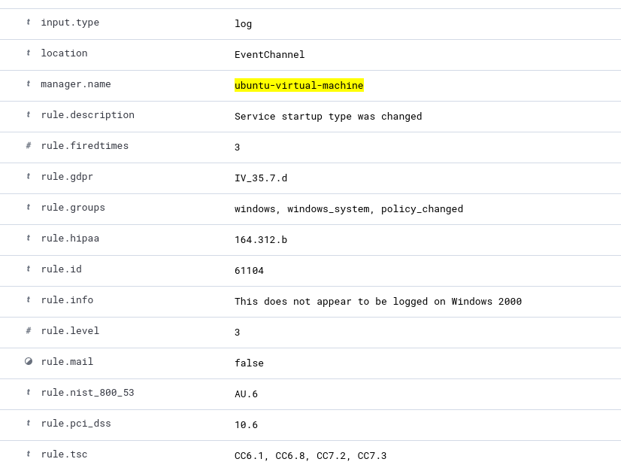

* Service startup type changing, let’s create a rule to make this clearer and for the rule to recognizable specific to the windows device.

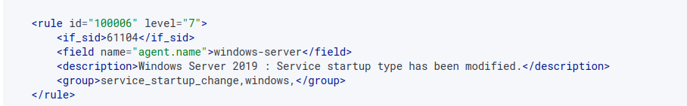

* Rule created to help with visibility, we will now only get this rule if the agent is the Windows Server hence specifying the rule further.

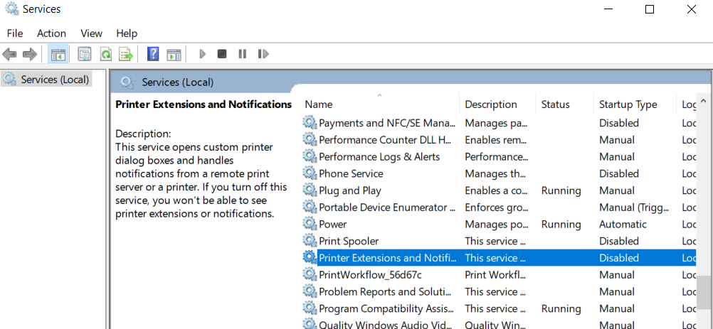

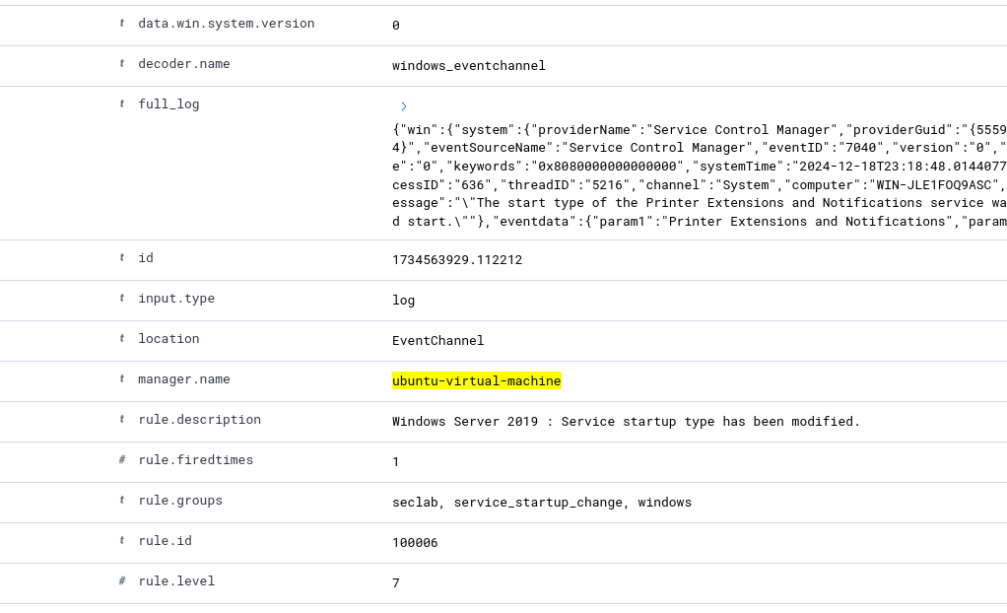

* Alert now triggers with an additional rule that helps us understand where everything is happening and what the issue is and hence increasing visibility.

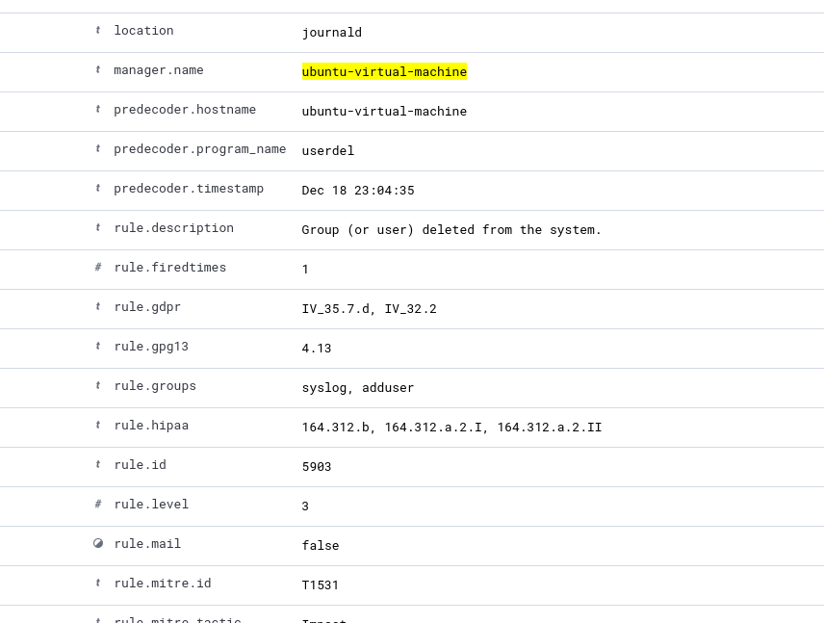

* User has been deleted, let’s create a rule to make this clearer and for the rule to recognizable specific to the ubuntu device.

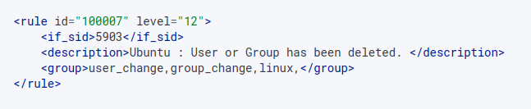

* Rule created to help with visibility, we will now only get this rule if the agent is the Ubuntu Agent machine hence specifying the rule further.’

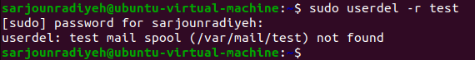

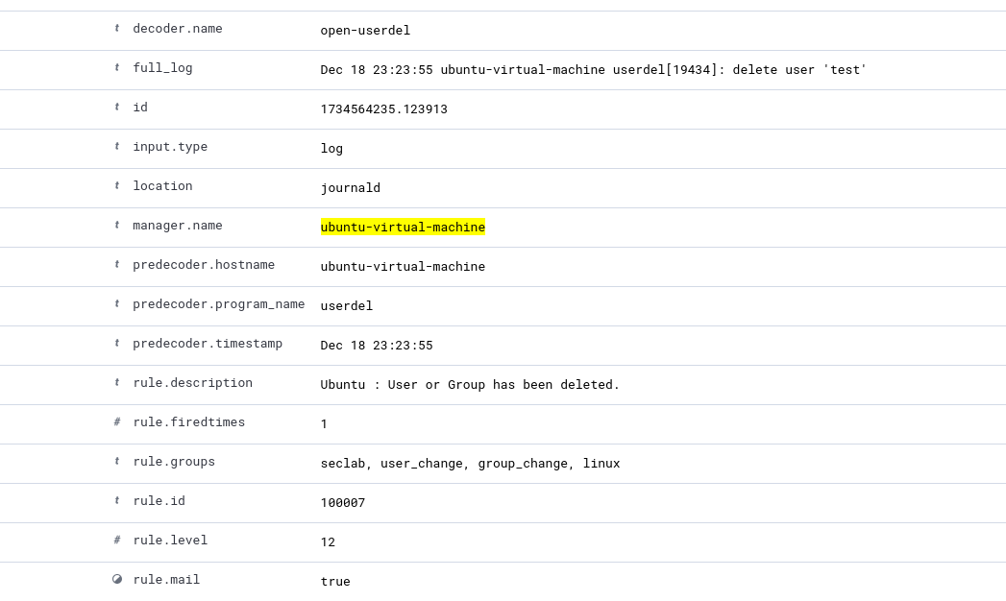

* Alert now triggers with an additional rule that helps us understand where everything is happening and what the issue is and hence increasing visibility.

**STEP 6 NOTE: I ONLY DID THESE RULES AS A SAMPLE, MANY MORE CAN BE CREATED HOWEVER THIS QUESTION WASN’T THAT SPECIFIC SO I JUST SHOWED ONE FOR EACH.**

# Step 7: Monitoring and Alerts

1. Create user on windows machine and check the event received in Wazuh

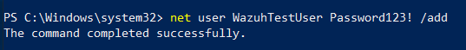

* Added a new user.

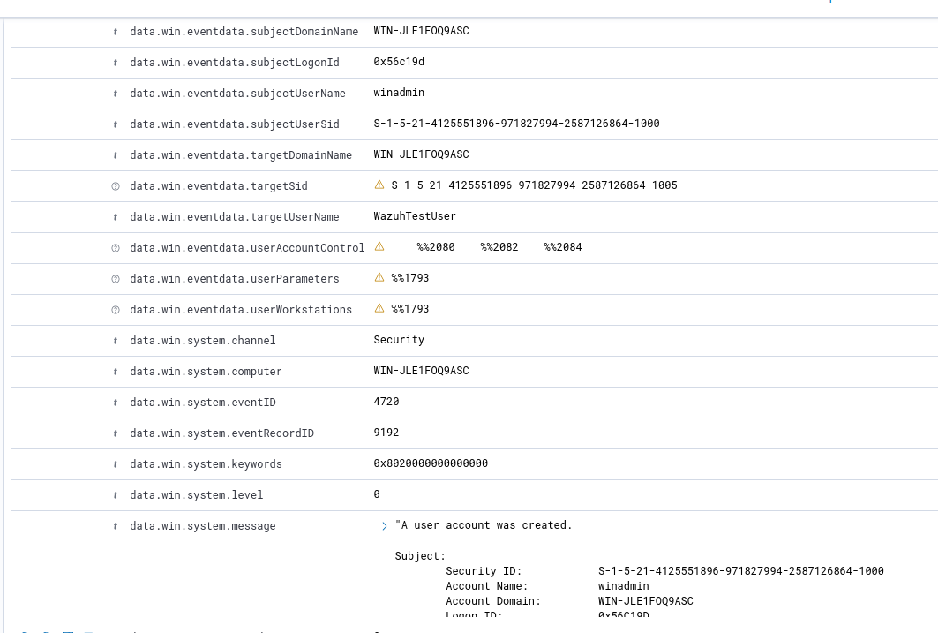

* Received alert on Wazuh showing the **targerUserName** who is the created user and the **message** which shows the full log from Event Viewer letting us know who created the user.

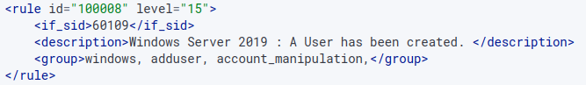

* Added a new rule for better visibility, specifying the device and choosing the groups as I want them to be to make searching for this easier/ more unique (ie: account_manipulation). I made the rule “critical” since my home lab is not a commercial setting where users are being added and deleted normally, I need to know this information.

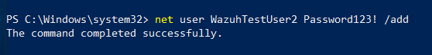

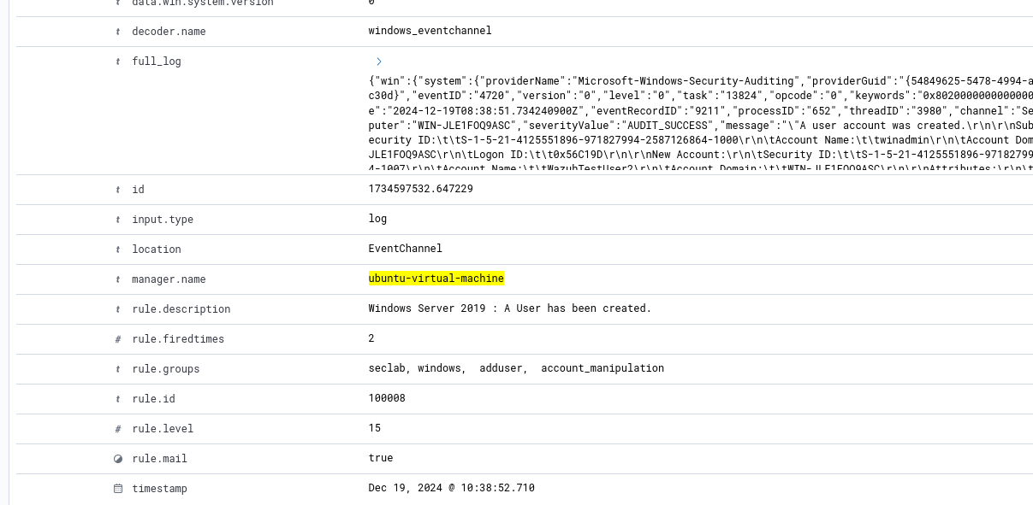

* We can see the new rule is being applied and helps with visibility since it has its own unique message (specific to the device since this is the only Windows device) and with unique groups (**seclab**, **account_manipulation**) to ensure we can easily search for events we care about more than the others/ that we made and need constant visibility on them.

1. Create user on Linux machine and check the event received in Wazuh

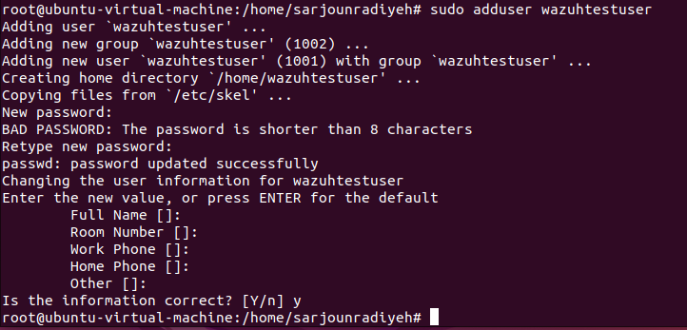

* Created a new user.

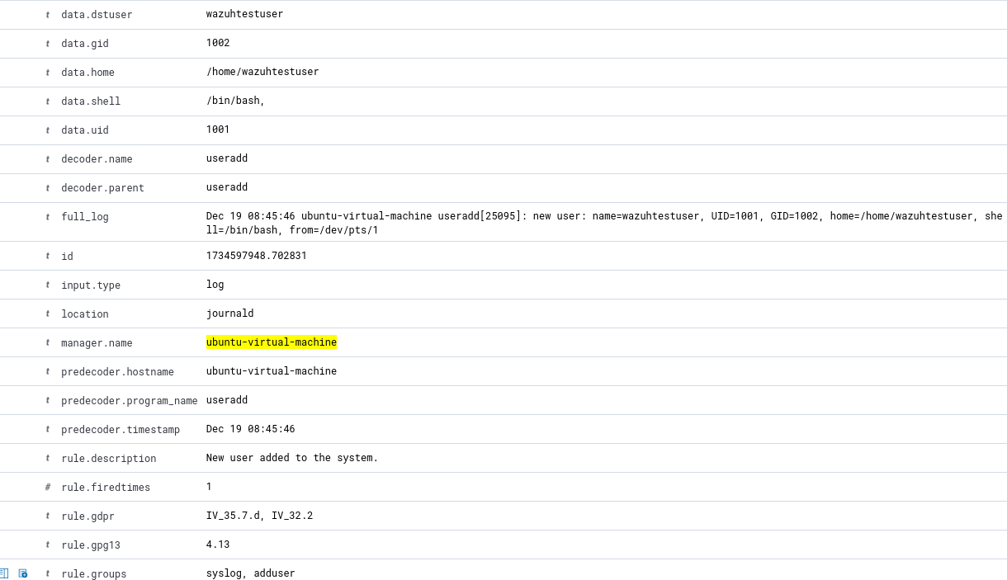

* Received alert on Wazuh showing the **data.dstuser** who is the created user and the alert which shows the **full_log** from letting us know who created the user.

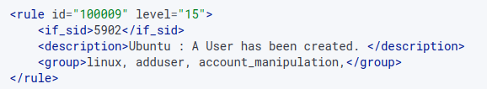

* Created new rule on Wazuh for better visibility, the rule has a more specific and clear message specifying the machine. I also added custom groups like “linux” and “account_manipulation” to help when trying to filter for this alert. I made the rule “critical” (level 15) since my home lab is not a commercial setting where users are being added and deleted normally, I need to know this information.

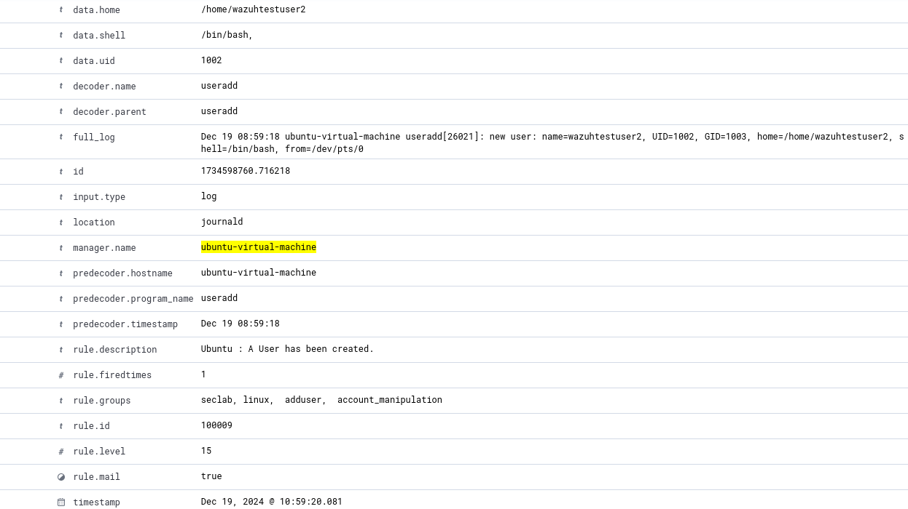

* We can see the new rule is being applied and helps with visibility since it has its own unique message (specific to the device since this is the only Ubuntu device) and with unique groups (**seclab**, **account_manipulation**) to ensure we can easily search for events we care about more than the others/ that we made and need constant visibility on them.

1. Add user to administrators’ group and check the event received in Wazuh



* Added a user to Administrators group.

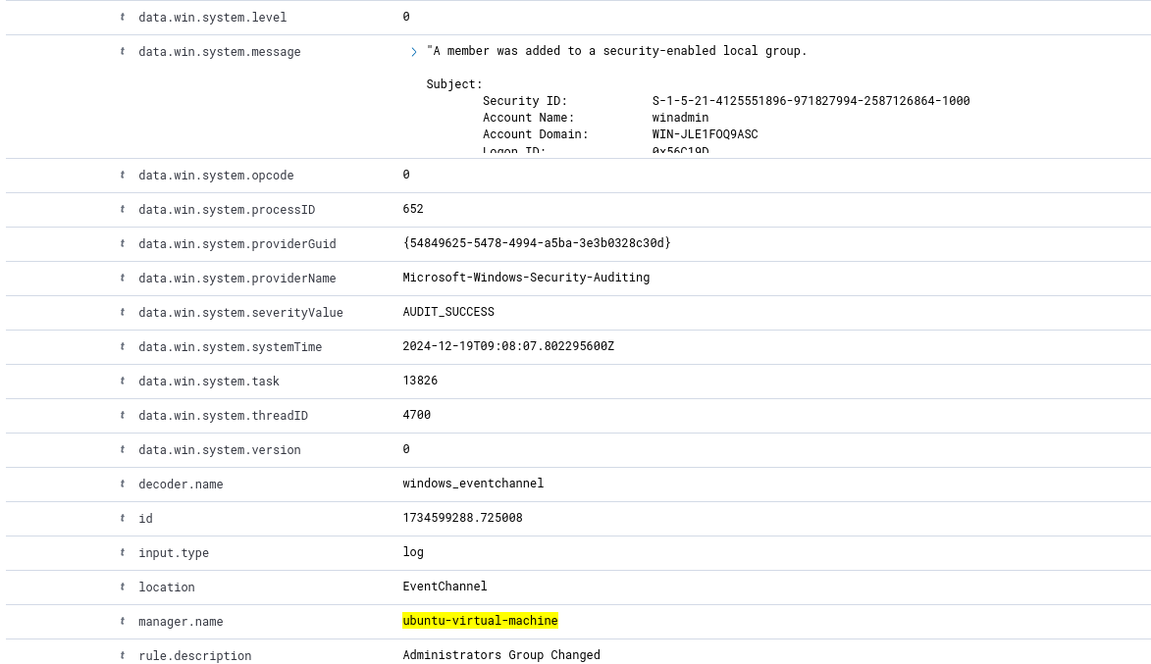

* Received alert on Wazuh showing and the alert shows the **data.win.system.message**, letting us know someone was added to the Administrators Group.

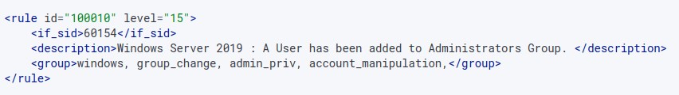

* Created new rule on Wazuh for better visibility, the rule has a more specific and clear message specifying the machine. I also added custom groups like “group_change” , “admin_priv” and “account_manipulation” to help when trying to filter for this alert. I made the rule “critical” (level 15) since any user gaining administrator privileges should be monitored very carefully, regardless of malicious intent or not.



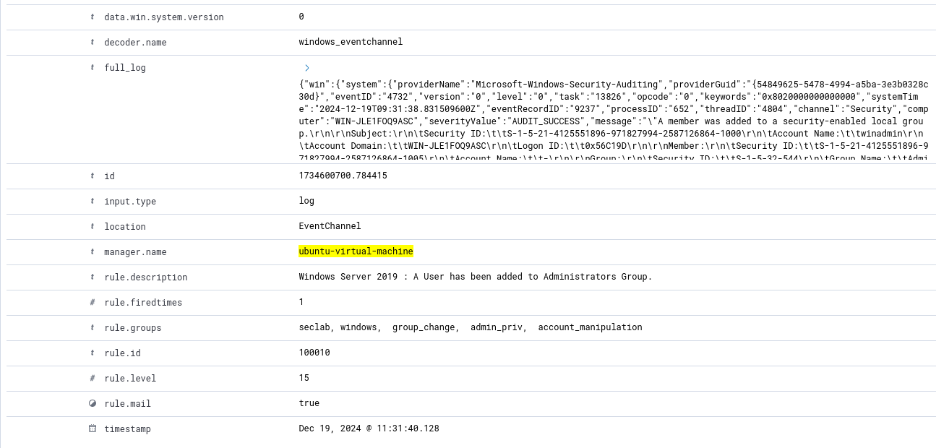

* We can see the new rule is being applied and helps with visibility since it has its own unique message (specific to the device since this is the only Windows device) and with unique groups (**seclab**, **group_change**, **admin_priv**, **account_manipulation**) to ensure we can easily search for events we care about more than the others/ that we made and need constant visibility on them.

1. Add user to sudoers group and check the event received in Wazuh



* Added user to sudoers group.

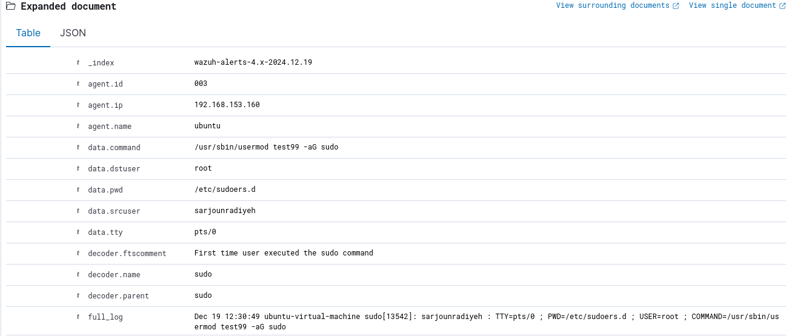

* User being added appeared on the alert.

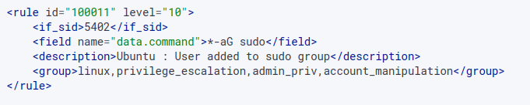

* Created rule to match id and field and to give out a specific description and specific groups to help with visibility.

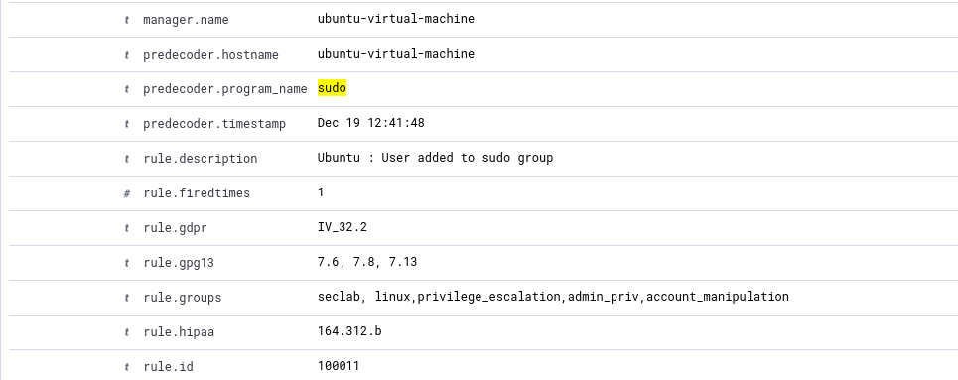

* Alert was triggered and the rule description along with the groups help in searching for specific alerts that I care about (mentioned before).

1. Disable user on Windows server and check the event received in Wazuh



* Disabled a user.

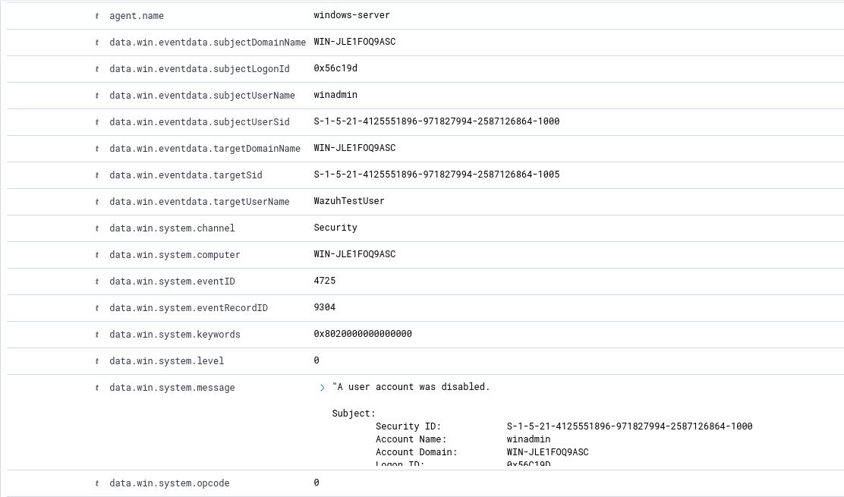

* Alert appeared clearly informing us who’s been disabled through **targerUserName** and who did it through **subjectUserName.**

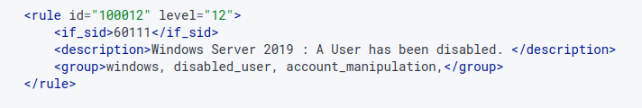

* Added new rule to enhance clarity and visibility of the alert.

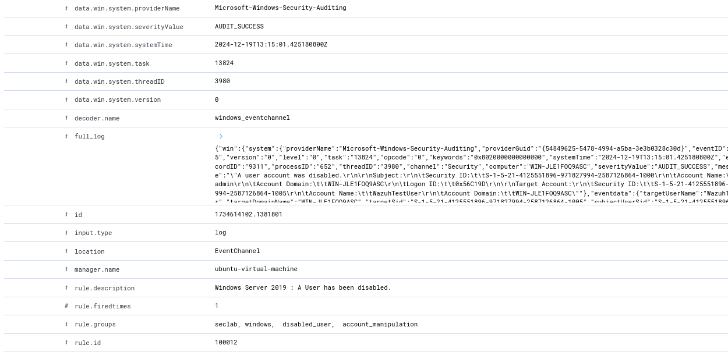

* We can see the new rule is being applied and helps with visibility since it has its own unique message (specific to the device since this is the only Windows device) and with unique groups (**seclab**, **disabled_user**, **account_manipulation**) to ensure we can easily search for events we care about more than the others/ that we made and need constant visibility on them.

1. Execute some commands like whoami, hostname, quser, adding rules on firewall and check the events in Wazuh (**quser is a Windows command so I’m assuming we’re meant to do this part for Windows only… hope I was correct**)

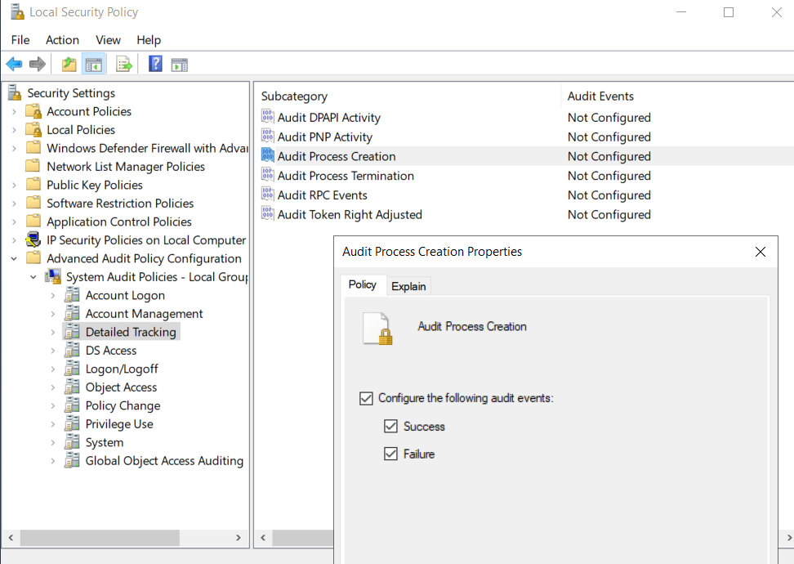

* For Wazuh to know If a command has been executed, we need to enable the logging of that in our Local Security Policy, I went to Detailed Tracking (you can see the other parent sets in the screenshot) and enabled Audit Process Creation on both Success and Failure to be able to see these commands get executed.

**whoami:**

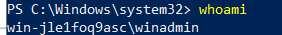

* Executed whoami command.

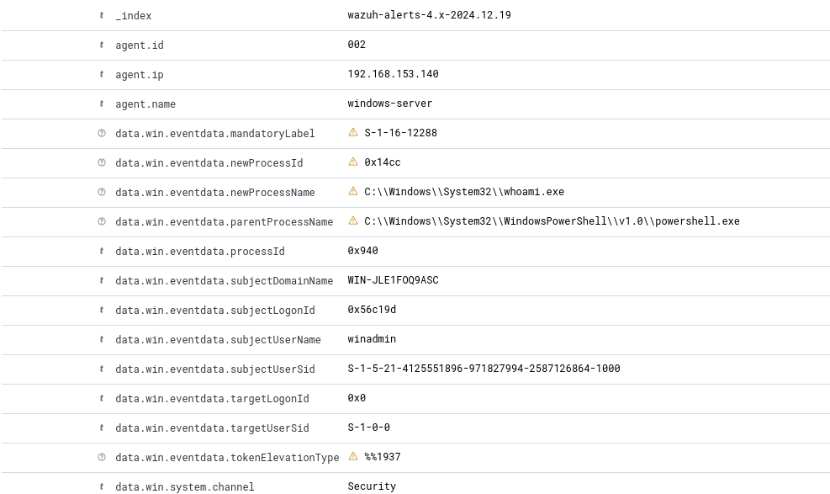

* Alert shows whoami.exe was executed , let’s create a more specific rule.

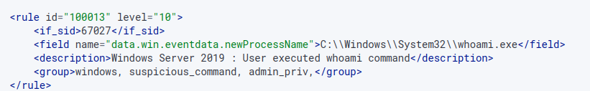

* Rule looks at field to specify the command in the description, field was very hard to use and I ran into a lot of problems making sure the rule works with field properly. Rule was level 10 (medium) as the command being executed is suspicious however not enough alone to warrant a high alert.

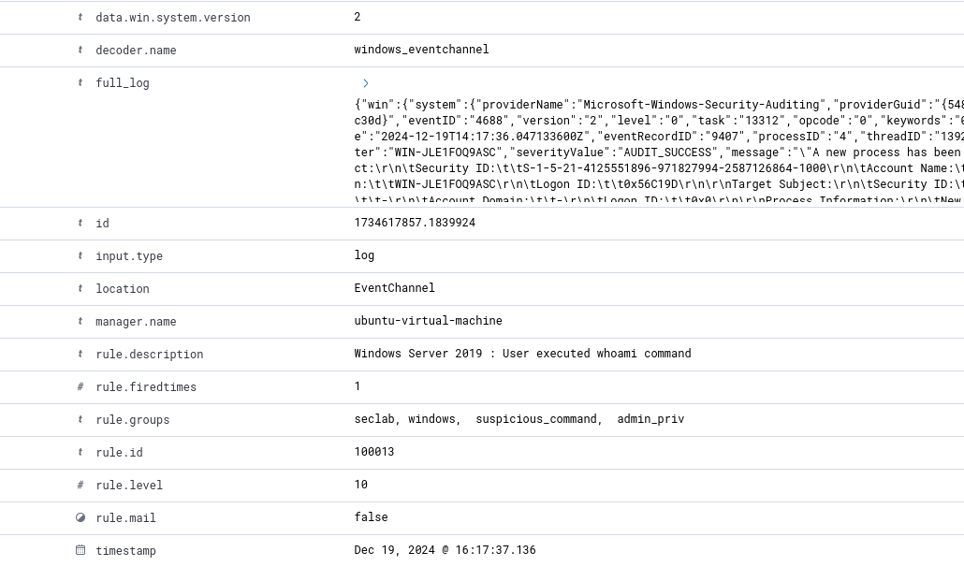

* We can see the new rule is being applied and helps with visibility since it has its own unique message (specific to the device since this is the only Windows device) and with unique groups (**seclab**, **suspicious_command**, **admin_priv**) to ensure we can easily search for events we care about more than the others/ that we made and need constant visibility on them.

**quser:**



* Executed quser command.

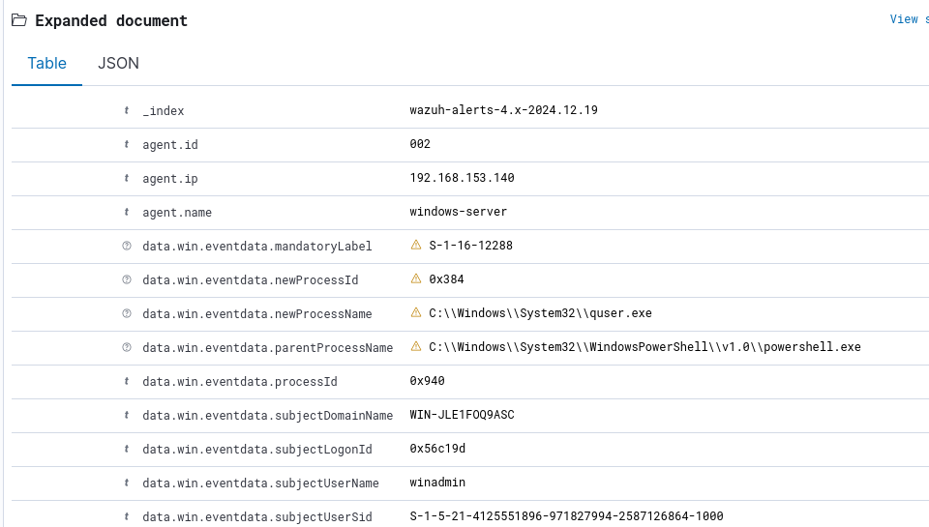

* Alert shows whoami.exe was executed , let’s create a more specific rule.

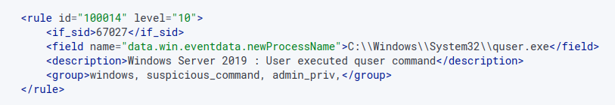

* Rule looks at field to specify the command in the description, level 10 (medium) as the command being executed is suspicious however not enough alone to warrant a high alert.

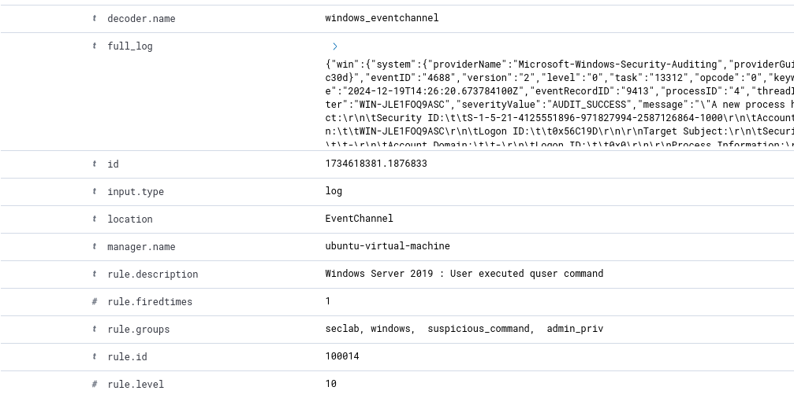

* We can see the new rule is being applied and helps with visibility since it has its own unique message (specific to the device since this is the only Windows device) and with unique groups (**seclab**, **suspicious_command**, **admin_priv**) to ensure we can easily search for events we care about more than the others/ that we made and need constant visibility on them.

**hostname:**

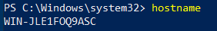

* Executed hostname command.

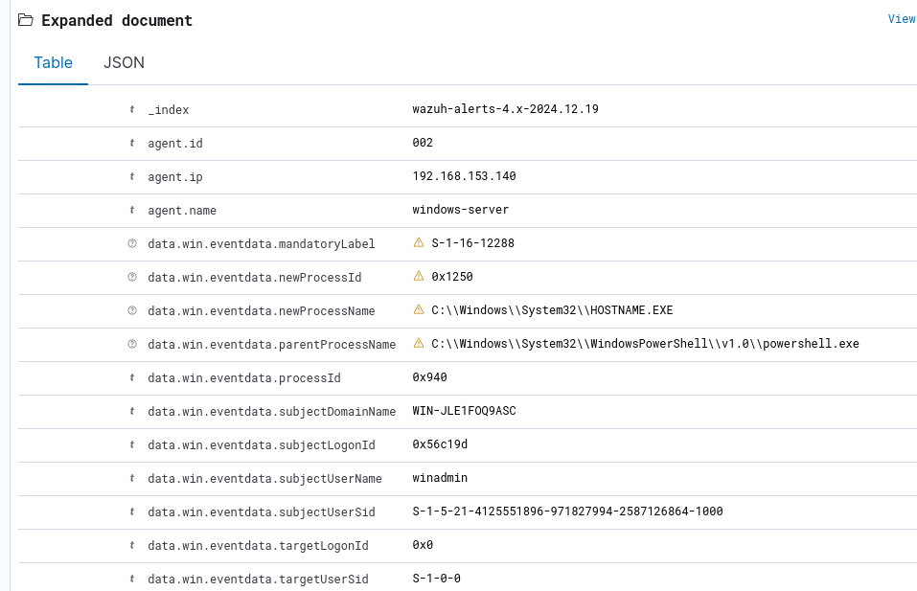

* Alert shows HOSTNAME.EXE was executed , let’s create a more specific rule.

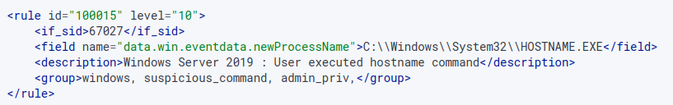

* Rule looks at field to specify the command in the description, level 10 (medium) as the command being executed is suspicious however not enough alone to warrant a high alert.

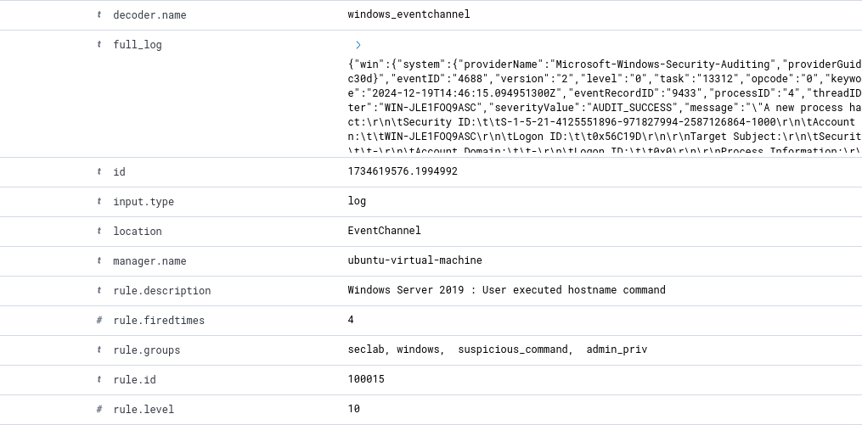

* We can see the new rule is being applied and helps with visibility since it has its own unique message (specific to the device since this is the only Windows device) and with unique groups (**seclab**, **suspicious_command**, **admin_priv**) to ensure we can easily search for events we care about more than the others/ that we made and need constant visibility on them.

**Firewall allow rule:**

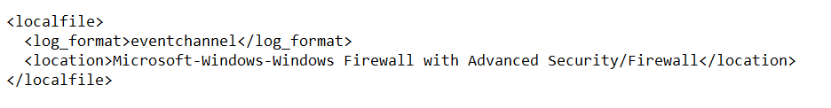

* Modified ossec.conf to allow Firewall logs to be collected and sent to Wazuh.



* Added a firewall rule.

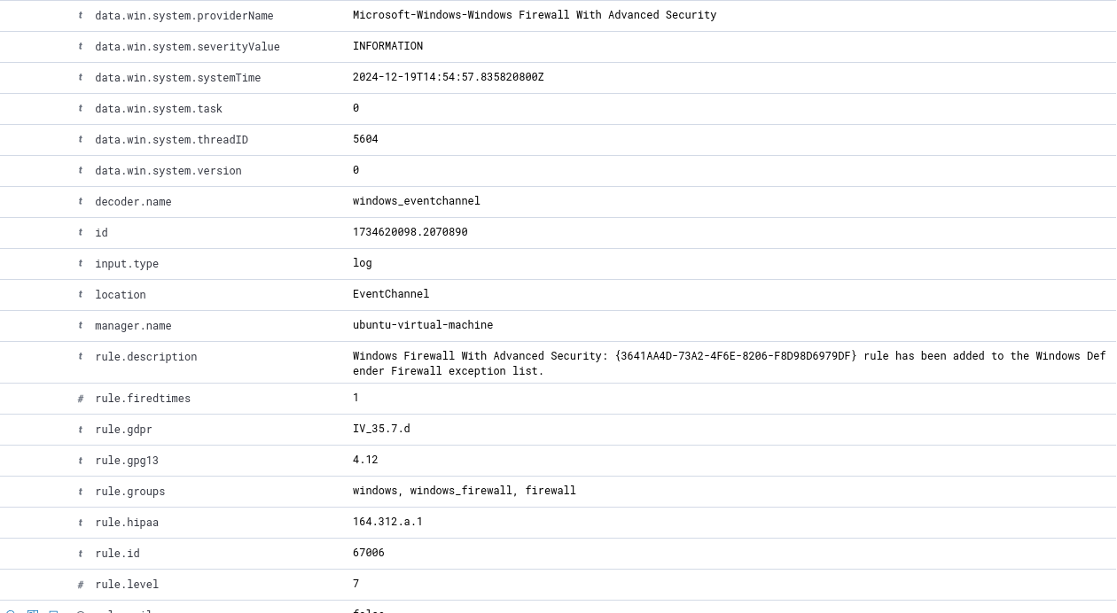

* Alert shows a firewall rule has been added along with what the exact rule was (not shown in this screenshot, can be seen below when clarity is added), let’s create a more specific rule.

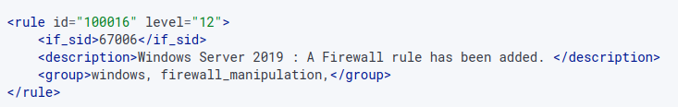

* Added a new rule to specify groups and description to make the alert more visible, rule level 12 (high) as a new rule can be a means of data exfiltration or an entry point.

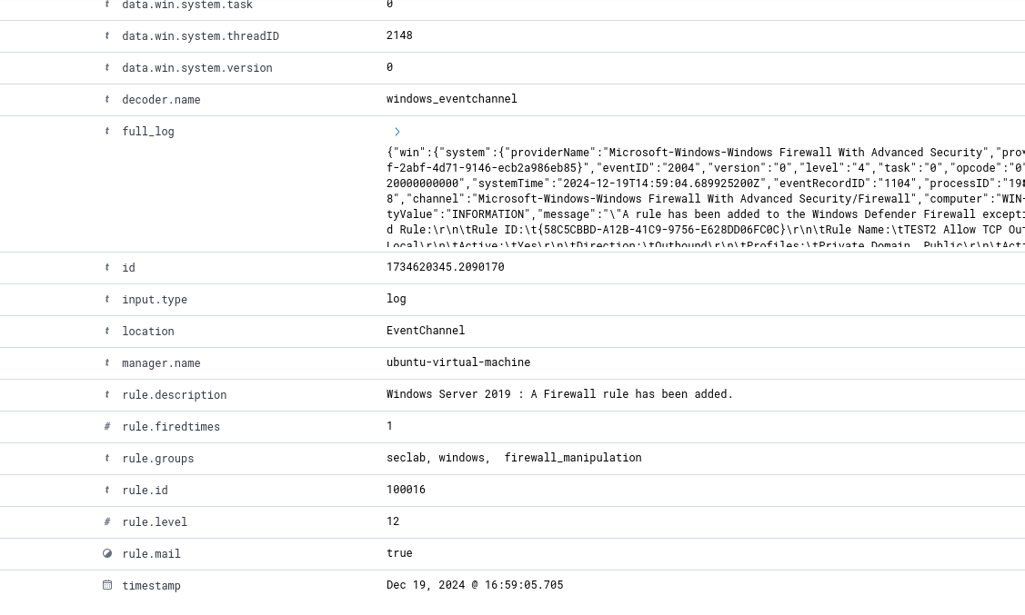

* We can see the new rule is being applied and helps with visibility since it has its own unique message (specific to the device since this is the only Windows device) and with unique groups (**seclab**, **firewall_manipulation**) to ensure we can easily search for events we care about more than the others/ that we made and need constant visibility on them. We can also see the exact details of the rule and its name, “TEST2 ALLOW TCP…”.

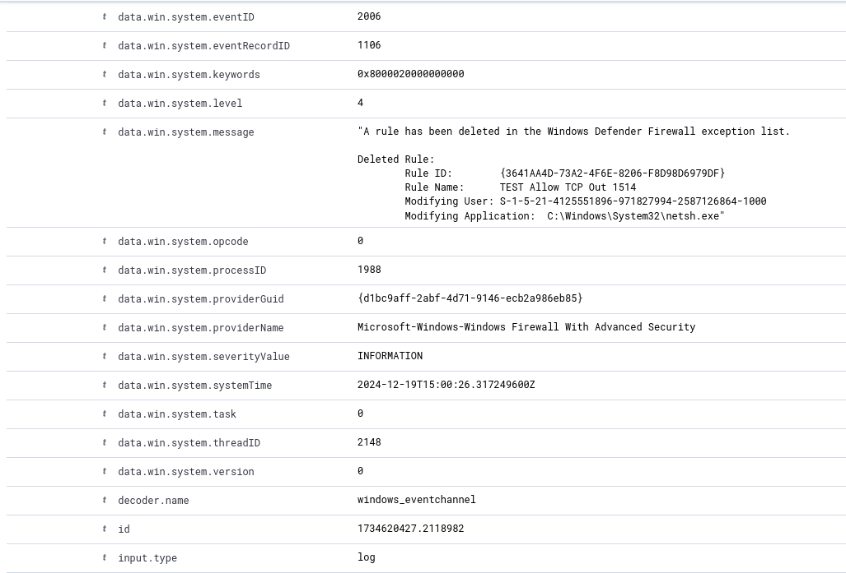

* We can also see firewall rule deletion (however I didn’t add a rule for more clarity).

1. Enable file integrity monitoring and monitor specific directories (FIM)

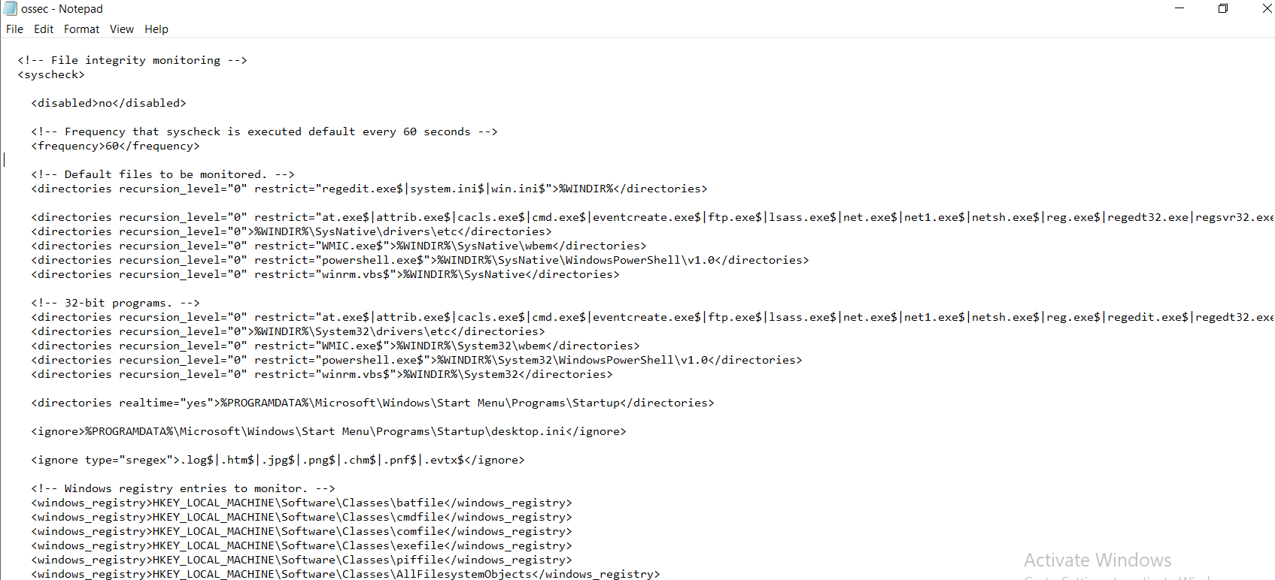

* File integrity monitoring is already enabled by default in the ossec.conf file, I just changed the frequency to every 1 minute instead of every 12 hours for the purpose of testing, we can see that a lot of programs, directories and registries are monitored by default.

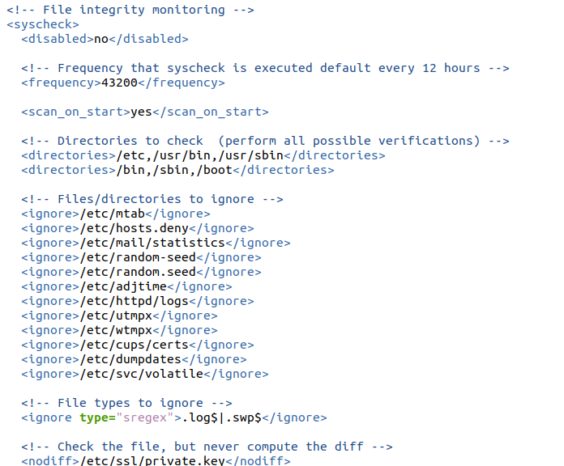

* Exact same case for Linux machines however the default directories are changed to match the system.
* I will be moving forward with just Windows for testing, however the exact same logic applies.

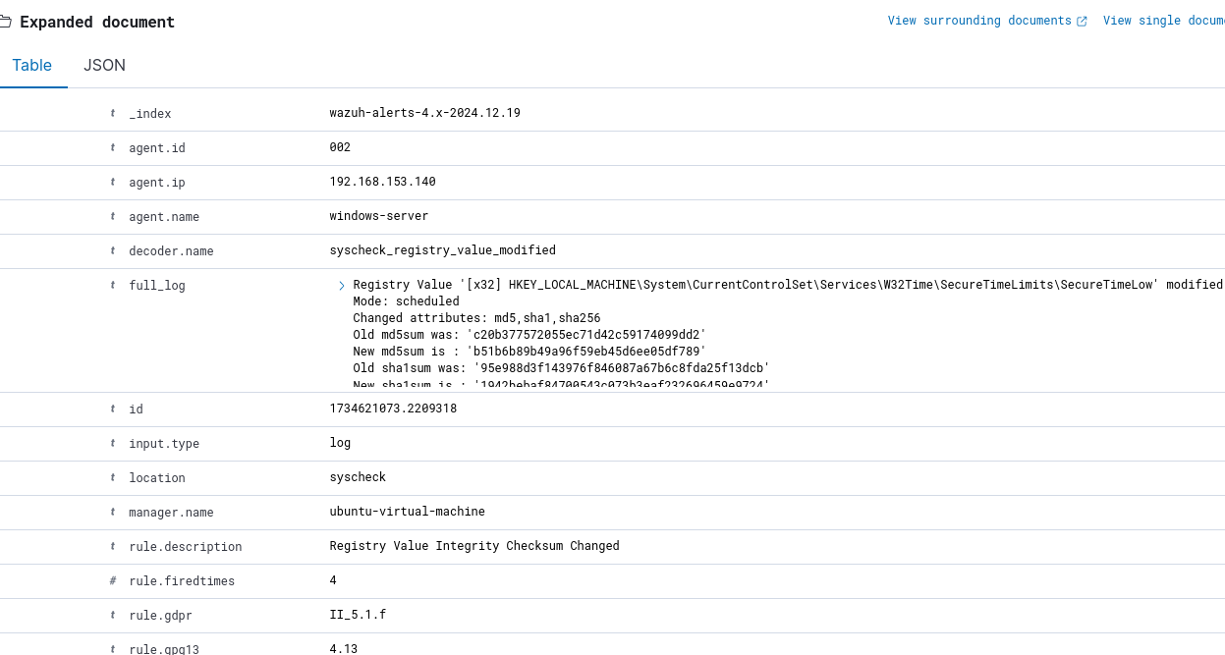

* We can see here a registry value has been changed (probably for no suspicious reason however it is logged regardless) with the **full_log** explaining the exact details of the change.

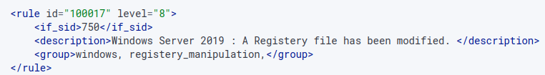

* Added a rule for further clarity and grouping.

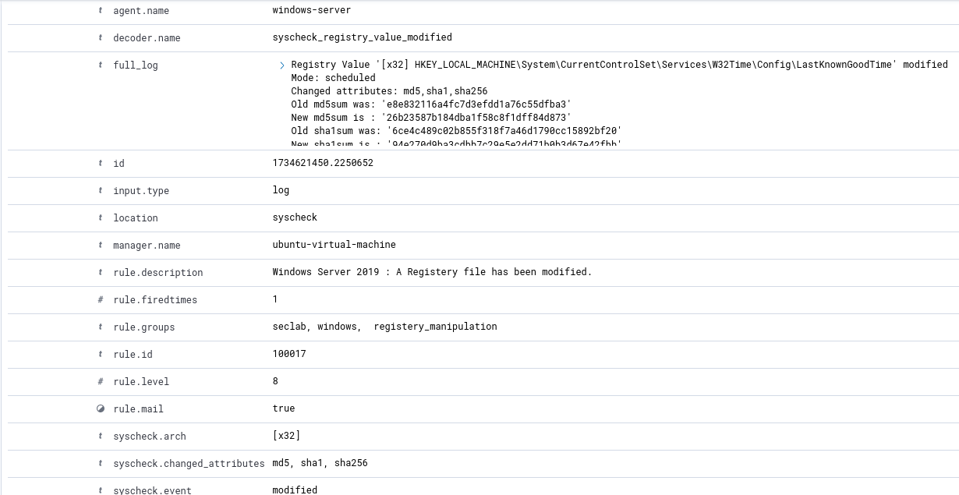

* We can see the new rule is being applied and helps with visibility since it has its own unique message (specific to the device since this is the only Windows device) and with unique groups (**seclab**, **registery_manipulation**) to ensure we can easily search for events we care about more than the others/ that we made and need constant visibility on them.

1. Integrate with VirusTotal to monitor malicious files and hashes

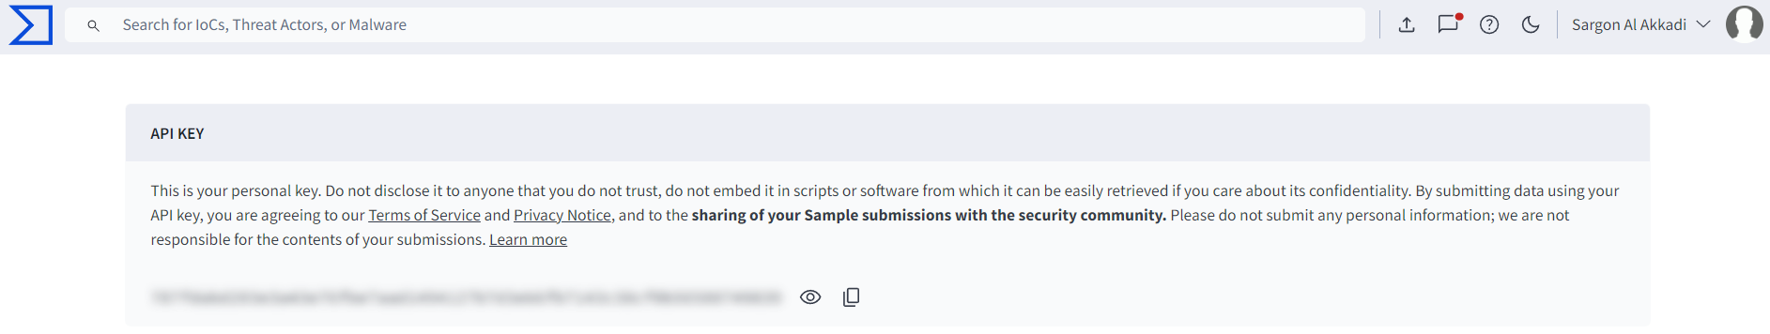

* Obtained my API key from VirusTotal to use it in the integration process.

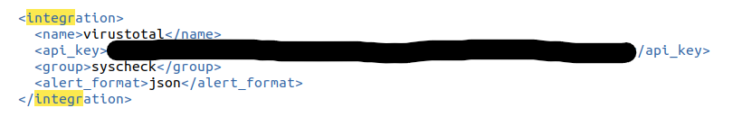

* Added the integration to ossec.conf.

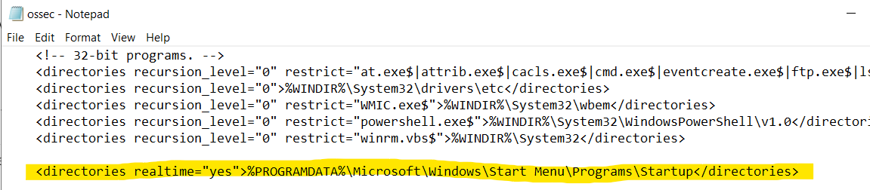

* Noticed one of the directories being monitored is the Startup one.

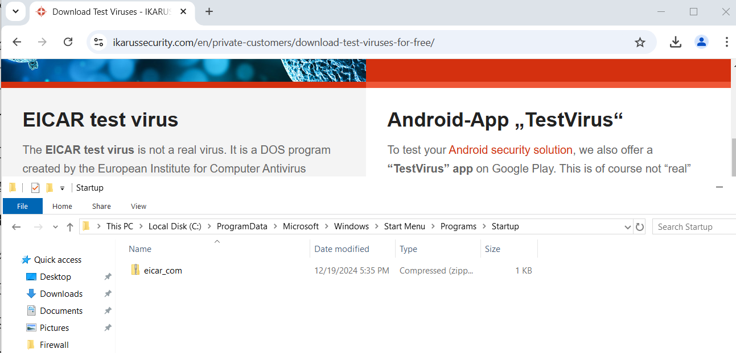

* Downloaded test virus and placed it in the Startup directory for testing.

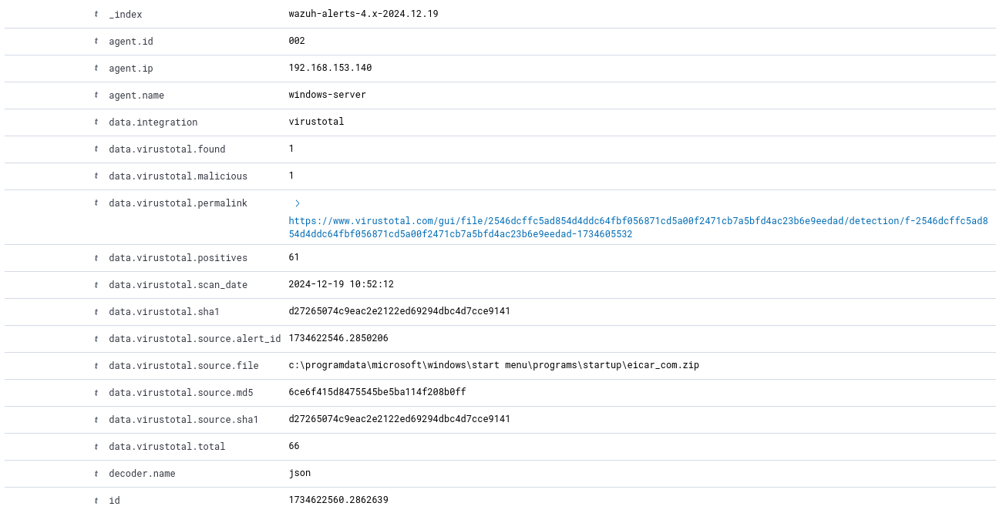

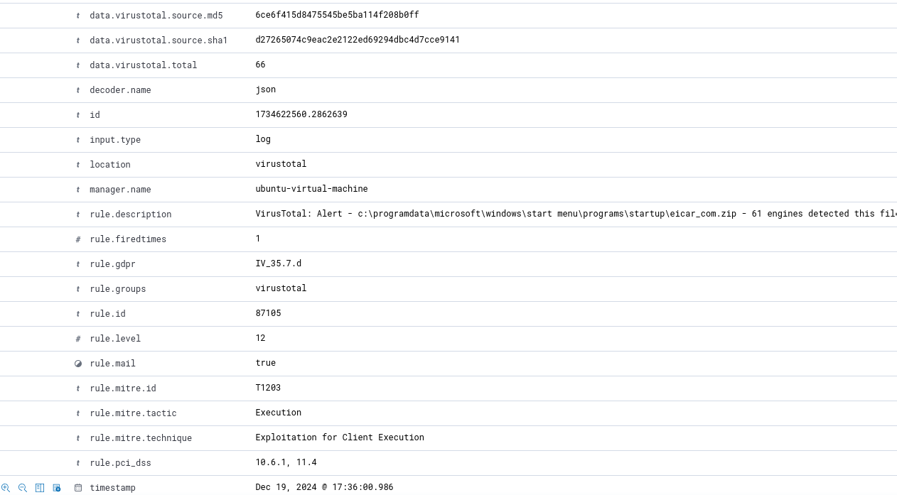

* VirusTotal analyze the file that was caught by syscheck (FIM) and found out it was a virus and warned us of its presence, location (**virustotal.source.file**) and purpose (**mitre.technique**).

1. Create some alerts based on the events received**. (I WILL BE USING SLACK FOR ALERTING)**

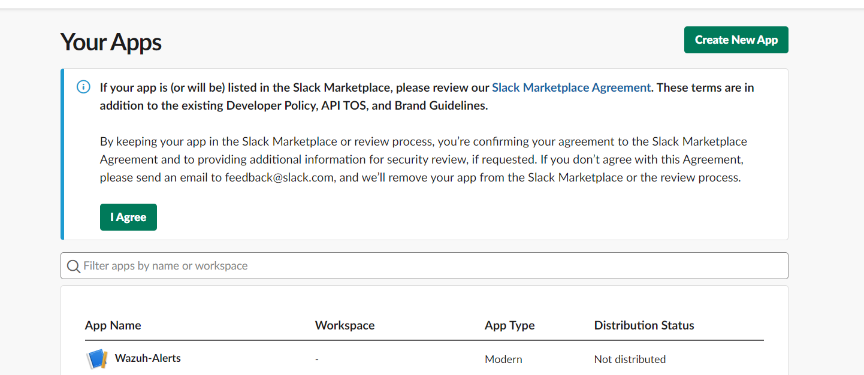

* Created a slack app for the purpose of retrieving Wazuh Alerts.

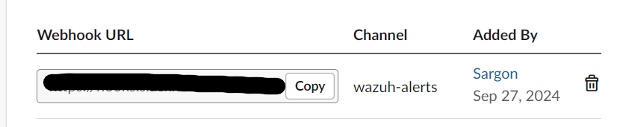

* Created a Incoming Webhook URL for the purpose of integration (this was made a while ago, which explains the date).

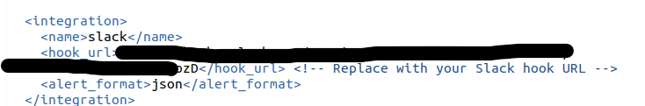

* Added the webhook URL in my slack integration configuration in the ossec.conf file.

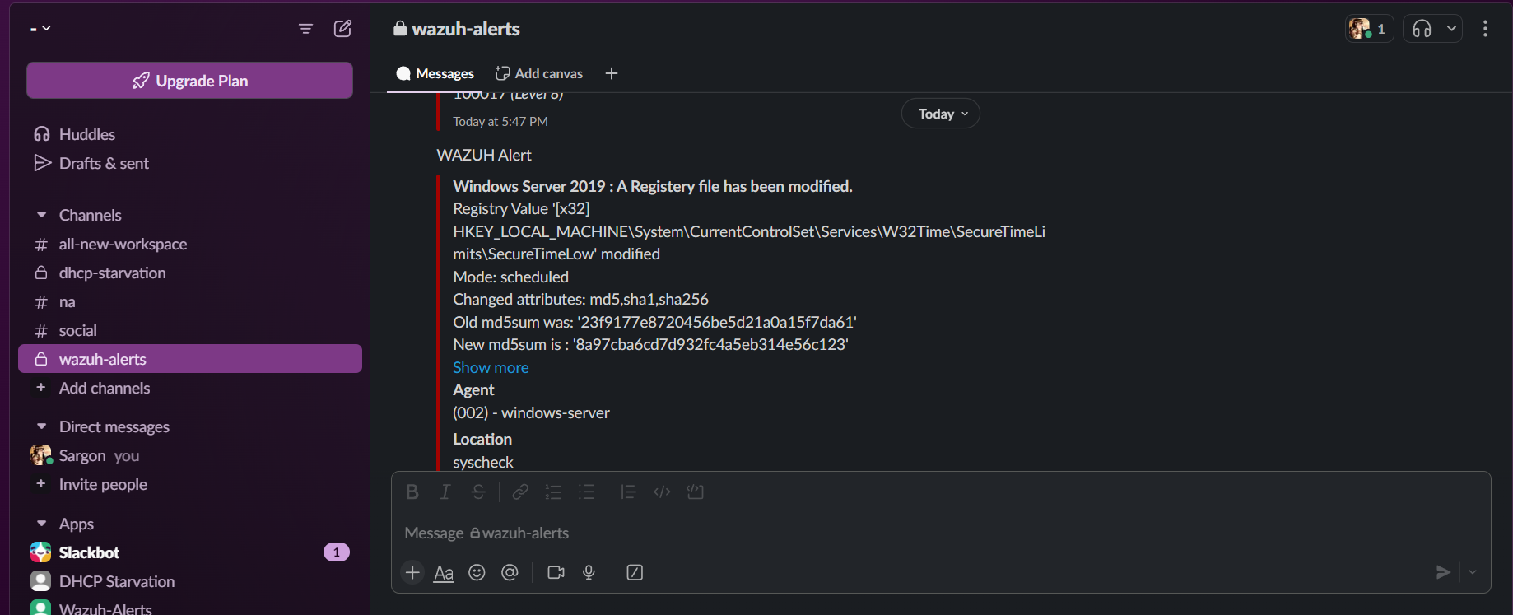

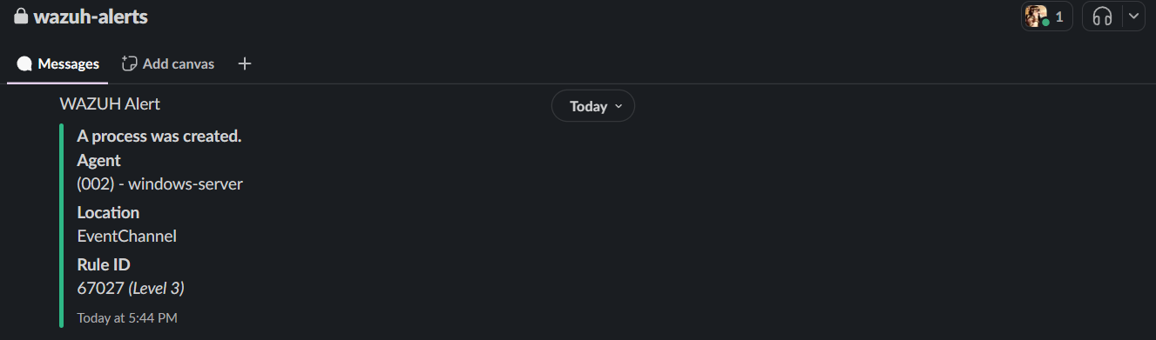

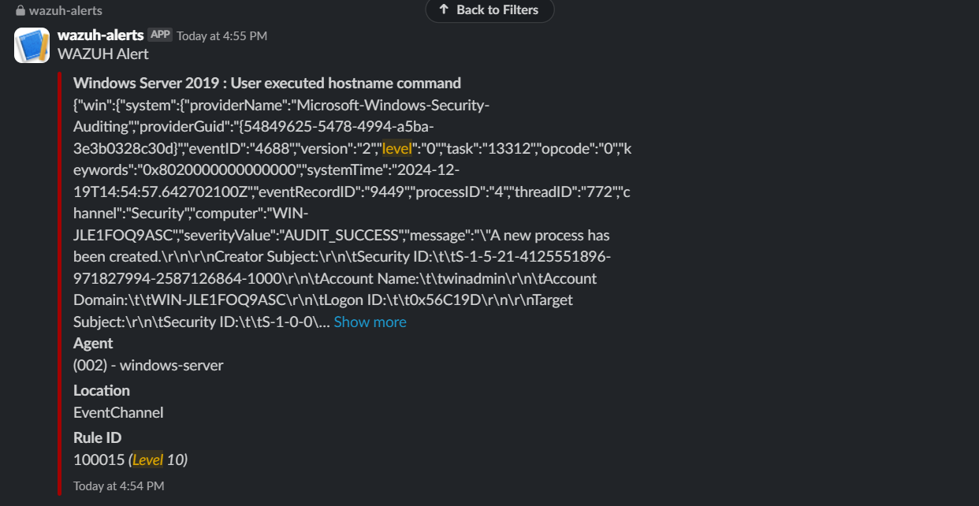

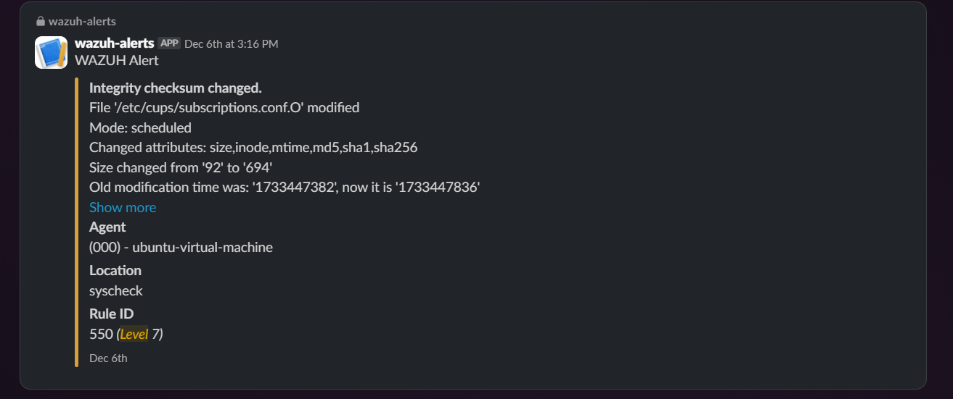

* We can now see all our Wazuh Alerts (regardless of whether it’s custom or not) with all the detail we need, most importantly rule level, rule id, rule description, for quick analysis.